Static Computational Graphs
Definition
A static computational graph (also known as a deferred execution graph) is a fixed graph that is defined and compiled before any computations are executed. Once the graph is constructed, it remains unchanged during the execution phase.
Characteristics
- Predefined Structure:
  - The entire computation is defined upfront.
  - All operations and their connections are specified before running the model.
- Optimization:
  - Since the graph structure is known in advance, TensorFlow can perform various optimizations to enhance performance, such as operation fusion and memory optimization.
- Execution:
  - Execution happens within a session (tf.Session in TensorFlow 1.x), where the graph is run with specific input data.
- Reusability:
  - The same graph can be reused for multiple runs with different input data, promoting efficiency.
Advantages
- Performance Optimization:
  - Allows for extensive graph-level optimizations, leading to faster execution times.
- Scalability:
  - Well-suited for deploying models in production environments where performance and resource utilization are critical.
- Resource Management:
  - Efficiently manages memory and computational resources by optimizing the execution path.
Disadvantages
- Flexibility:
  - Less intuitive and harder to debug since the graph is not visible during execution.
- Development Overhead:
  - Requires a separate graph construction phase and session management, adding complexity to the development process.
- Dynamic Behaviors:
  - Handling dynamic control flows (e.g., loops with variable iterations) can be cumbersome and less straightforward.
Example in TensorFlow 1.x
import tensorflow as tf

# Define the computational graph
a = tf.placeholder(tf.float32)
b = tf.placeholder(tf.float32)
c = a + b

# Create a session to run the graph
with tf.Session() as sess:
result = sess.run(c, feed_dict={a: 2.0, b: 3.0})
print("Result:", result) # Output: Result: 5.0
In this example, the graph is defined with placeholders a and b, and the operation c = a + b is added to the graph. The session is then used to execute the graph with specific input values.

Dynamic Computational Graphs
Definition
A dynamic computational graph (also known as a define-by-run graph) is constructed on-the-fly during the execution of the program. The graph is built incrementally as operations are invoked, allowing for greater flexibility and ease of use.
Characteristics
- On-the-Fly Construction:
  - The graph is built dynamically as operations are called, enabling immediate feedback and interaction.
- Intuitive Debugging:
  - Easier to debug since operations are executed immediately, and errors can be identified in real-time.
- Flexibility:
  - Supports dynamic control flows, such as loops and conditional statements, with varying numbers of iterations or branches.
- No Separate Session Management:
  - Operations are executed immediately without the need for a separate session, simplifying the development workflow.
Advantages
- Ease of Use:
  - More intuitive and similar to standard Python programming, lowering the barrier to entry for beginners.
- Dynamic Behaviors:
  - Naturally handles dynamic architectures and control flows, making it suitable for research and experimentation.
- Interactive Development:
  - Facilitates interactive development and rapid prototyping, as changes can be tested immediately.
Disadvantages
- Performance Overhead:
  - Limited opportunity for global graph optimizations, potentially leading to slower execution compared to static graphs.
- Resource Management:
  - May consume more memory and computational resources due to the lack of pre-execution optimizations.
- Scalability:
  - Less optimized for large-scale production deployments where performance is critical.
Example in TensorFlow 2.x
import tensorflow as tf

# Define and execute operations on-the-fly
a = tf.constant(2.0)
b = tf.constant(3.0)
c = a + b
print("Result:", c.numpy()) # Output: Result: 5.0
In this example, operations are executed immediately as they are defined, and the result can be accessed directly without the need for a session.

Hybrid Approach with tf.function
- tf.function:
  - A decorator that compiles a Python function into a static graph, allowing TensorFlow to perform optimizations while maintaining the flexibility of dynamic execution during development.
- Benefits:
  - Combines the ease of use and flexibility of dynamic graphs with the performance optimizations of static graphs.
- Usage:
  - Developers can write code in an imperative style and selectively compile parts of the code that require performance optimizations.
Example: Using tf.function
import tensorflow as tf

@tf.function
def add(a, b):
return a + b

# Define tensors
a = tf.constant(2.0)
b = tf.constant(3.0)

# Execute the function
result = add(a, b)
print("Result:", result.numpy()) # Output: Result: 5.0
In this example, the add function is compiled into a static graph, benefiting from TensorFlow's optimizations while still allowing for dynamic execution during development.

🔹 What Is Eager Execution?
It allows TensorFlow operations to run instantly, returning concrete values (tensors), rather than building a graph to run later.
Introduced in TensorFlow 2.x, eager execution is enabled by default.

🧠 Why It Matters
Without Eager Execution (TF 1.x) | With Eager Execution (TF 2.x)
Build a computation graph first | Operations execute immediately
Delayed execution | Immediate results
Less intuitive, more code | Pythonic and user-friendly
Harder to debug | Easy to debug (use print())

🧪 Example of Eager Execution
import tensorflow as tf

# Enabled by default in TF 2.x
a = tf.constant([[1, 2], [3, 4]])
b = tf.constant([[5, 6], [7, 8]])

# Immediate execution
result = tf.matmul(a, b)
print(result)
✅ Output:
tf.Tensor(
[[19 22]
[43 50]], shape=(2, 2), dtype=int32)

✅ Advantages of Eager Execution
Advantage | Benefit
Debugging | Easy to inspect values with print() or pdb.
Simplicity | Write TensorFlow like regular Python code.
Dynamic control flow | Supports loops, if, recursion naturally.
Integration | Plays well with Python libraries like NumPy.

❌ Disadvantages of Eager Execution
Disadvantage | Description
Slightly Slower | Less optimized than static graphs in some cases.
Harder to Export | Deployment may require conversion to a SavedModel.
No built-in optimization | You lose some of the compiler-level speedup.

Defining Variables and Constants
Constants
A Constant in TensorFlow is an immutable tensor whose value cannot be changed after it is defined. Constants are used to hold fixed values that do not need to be updated during the execution of the computational graph, such as weights in certain layers or fixed hyperparameters.
- Creation:
import tensorflow as tf

# Creating a constant tensor
const_tensor = tf.constant([1, 2, 3], dtype=tf.int32)
print("Constant Tensor:", const_tensor)
Output:
Constant Tensor: tf.Tensor([1 2 3], shape=(3,), dtype=int32)
Variables
A Variable in TensorFlow is a mutable tensor that can be updated during the execution of the computational graph. Variables are typically used to store and update the parameters of machine learning models, such as weights and biases, during training.
- Creation:
# Creating a variable tensor
var_tensor = tf.Variable([1.0, 2.0, 3.0], dtype=tf.float32)
print("Variable Tensor:", var_tensor)
Output:
Variable Tensor: <tf.Variable 'Variable:0' shape=(3,) dtype=float32, numpy=array([1., 2., 3.], dtype=float32)>

Practical Example: Building a Simple Linear Model
Let's build a simple linear regression model using TensorFlow Variables and Constants.
import tensorflow as tf

# Define Constants for input data
X = tf.constant([[1.0], [2.0], [3.0], [4.0]], dtype=tf.float32) # Input features
Y = tf.constant([[2.0], [4.0], [6.0], [8.0]], dtype=tf.float32) # Target values

# Define Variables for model parameters (weights and bias)
W = tf.Variable([[0.0]], dtype=tf.float32, name='weight')
b = tf.Variable([0.0], dtype=tf.float32, name='bias')

# Define the linear model
def linear_model(X):
return tf.matmul(X, W) + b

# Define the loss function (Mean Squared Error)
def loss_fn(y_pred, y_true):
return tf.reduce_mean(tf.square(y_pred - y_true))

# Define the optimizer
optimizer = tf.optimizers.SGD(learning_rate=0.01)

# Training loop
for epoch in range(1000):
with tf.GradientTape() as tape:
y_pred = linear_model(X)
loss = loss_fn(y_pred, Y)

# Compute gradients
gradients = tape.gradient(loss, [W, b])

# Update variables
optimizer.apply_gradients(zip(gradients, [W, b]))

if epoch % 100 == 0:
print(f"Epoch {epoch}: Loss = {loss.numpy()}, W = {W.numpy()}, b = {b.numpy()}")

# Final model parameters
print("Trained Weights:", W.numpy())
print("Trained Bias:", b.numpy())
Output:
Epoch 0: Loss = 3.843950935333851e-07, W = [[1.9994855]], b = [0.00151244]
Epoch 100: Loss = 2.110404011546052e-07, W = [[1.9996188]], b = [0.00112094]
Epoch 200: Loss = 1.1597364846238634e-07, W = [[1.9997172]], b = [0.00083099]
Epoch 300: Loss = 6.37396198044371e-08, W = [[1.9997903]], b = [0.00061598]
Epoch 400: Loss = 3.504415246879944e-08, W = [[1.9998444]], b = [0.00045686]
Epoch 500: Loss = 1.9282310859125573e-08, W = [[1.9998846]], b = [0.00033888]
Epoch 600: Loss = 1.0611771017465799e-08, W = [[1.9999144]], b = [0.00025116]
Epoch 700: Loss = 5.822698767588008e-09, W = [[1.9999367]], b = [0.00018611]
Epoch 800: Loss = 3.2071767464003642e-09, W = [[1.9999528]], b = [0.00013822]
Epoch 900: Loss = 1.7866028656499111e-09, W = [[1.9999651]], b = [0.00010308]
Trained Weights: [[1.9999743]]
Trained Bias: [7.599345e-05]
Term | Meaning
W (Weights) | Controls the importance of each input feature. Think of it as "how much" each input contributes to the output.
b (Bias) | A constant value added to shift the output — even when input is zero. Helps the model fit better when data isn't centered at origin.

Feature | tf.constant | tf.Variable
Mutability | Immutable (cannot be changed) | Mutable (can be updated)
Use Case | Inputs, fixed values | Model parameters (e.g., weights, biases)
Trainable | ❌ Not trainable | ✅ Trainable

Great question!
🔁 What are Gradients?
Gradients are partial derivatives of the loss function with respect to the model's parameters (weights and biases).
They tell us how much a small change in a parameter will affect the loss.

🎯 Why are Gradients used in Neural Networks?
Gradients are used to update the weights of a neural network during training using a method called gradient descent.

🧠 Intuition:
Imagine you're standing on a hill (high loss) and you want to reach the valley (minimum loss).
Gradients point in the steepest uphill direction — so you move in the opposite direction to reduce the loss.

⚙️ In Technical Terms:
Let’s say we have a loss function L(w, b).
- ∂L/∂w: Gradient of loss with respect to weight
- ∂L/∂b: Gradient of loss with respect to bias
These gradients tell us how to adjust w and b to reduce the loss.

🔄 The Weight Update Rule (Gradient Descent):
w = w - learning_rate * ∂L/∂w
b = b - learning_rate * ∂L/∂b
- learning_rate controls the step size
- Negative sign because we move towards the minimum

📌 In TensorFlow:
In this code:
with tf.GradientTape() as tape:
y_pred = model(X)
loss = loss_fn(y_pred, y_true)

gradients = tape.gradient(loss, [W, b])
- tape.gradient() computes the gradients
- These are then applied using an optimizer:
optimizer.apply_gradients(zip(gradients, [W, b]))

🤖 Why Are They Crucial in Deep Learning?
- Without gradients, the model can’t learn.
- Gradients drive backpropagation, the core algorithm for training deep neural networks.

Let me know if you want a visual analogy or animation suggestion to make this even more intuitive!

What is a Neural Network?
A neural network is a computational model inspired by the way biological neural networks in the human brain operate. It consists of interconnected groups of nodes (neurons) that work together to process input data and produce output.
Basic Structure of a Neural Network
A typical neural network consists of three types of layers:
- Input Layer:
  - The first layer that receives the input features. Each neuron in this layer corresponds to one feature of the input data.
- Hidden Layers:
  - One or more layers where the actual computation takes place. Each neuron in a hidden layer applies a transformation to the inputs and passes its output to the next layer. The complexity of the model often increases with the number of hidden layers.
- Output Layer:
  - The final layer that produces the output of the network. The number of neurons in this layer corresponds to the number of classes in a classification task or a single neuron for regression tasks.
How Neural Networks Work
1. Forward Propagation:
- During the forward pass, input data is fed into the network, and each neuron applies a linear transformation followed by a non-linear activation function. The output of each neuron is computed as:
z = wx + b
Where w is the weight, x is the input, and b is the bias. The output of the neuron is then:
a = activation(z)
2. Backpropagation:
- After computing the output, the model's performance is evaluated using a loss function. The backpropagation algorithm calculates the gradients of the loss with respect to each weight and bias, allowing the model to update its parameters to minimize the loss.
3. Training Process:
- The network is trained over multiple epochs using a dataset, adjusting the weights and biases based on the gradients computed during backpropagation. The optimization of these parameters is typically done using techniques like stochastic gradient descent (SGD) or Adam.
Types of Neural Networks
1. Feedforward Neural Networks:
- The simplest type of neural network where connections between nodes do not form cycles. Information moves in one direction—from input to output.
2. Convolutional Neural Networks (CNNs):
- Specialized neural networks for processing grid-like data, such as images. They utilize convolutional layers to capture spatial hierarchies and patterns.
3. Recurrent Neural Networks (RNNs):
- Designed for sequential data, such as time series or natural language. RNNs have connections that allow information to persist, enabling them to capture dependencies across sequences.
4. Generative Adversarial Networks (GANs):
- Comprise two neural networks (generator and discriminator) that compete against each other, allowing for the generation of new data samples similar to a training dataset.
Applications of Neural Networks
Neural networks are widely used across various fields, including:
- Image Recognition: Detecting and classifying objects in images.
- Natural Language Processing: Understanding and generating human language.
- Speech Recognition: Converting spoken language into text.
- Medical Diagnosis: Analyzing medical data for disease prediction.

What is an Activation Function?
An activation function determines the output of a neuron given a set of inputs. It takes the weighted sum of inputs and applies a non-linear transformation, allowing the network to learn complex patterns in the data.
Types of Activation Functions
1. Sigmoid Function:
- Formula:
σ(x)=1/1+e−xσ(x)=1/1+e−x
- Range: (0, 1)
- Properties:
  - Smooth gradient and easy to interpret as a probability.
  - Prone to vanishing gradient problem for very high or low inputs.
- Use Cases: Mainly used in binary classification problems.
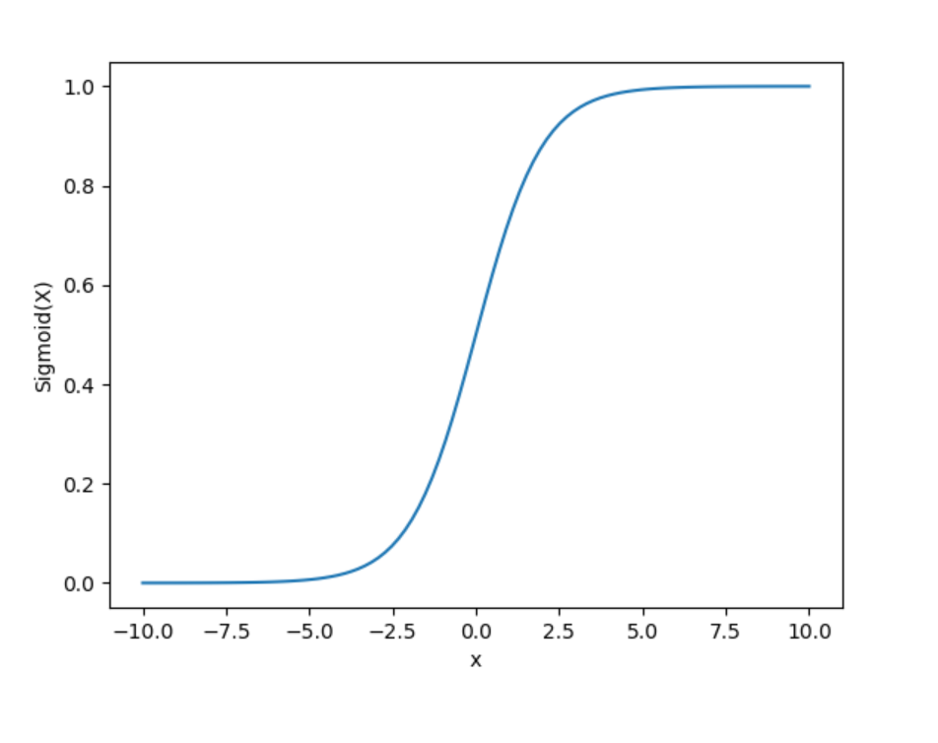
2. Hyperbolic Tangent (tanh):
- Formula:
tanh(x)=(ex−e−x)/(ex+e−x)tanh(x)=(ex−e−x)/(ex+e−x)
- Range: (-1, 1)
- Properties:
  - Outputs are zero-centered, which helps in faster convergence.
  - Also suffers from the vanishing gradient problem.
- Use Cases: Often used in hidden layers of neural networks.
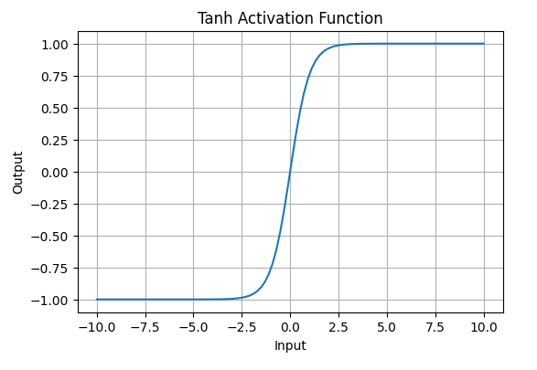

3. Rectified Linear Unit (ReLU):
- Formula:
f(x)=max(0,x)f(x)=max(0,x)
- Range: [0, ∞)
- Properties:
  - Computationally efficient and reduces the likelihood of vanishing gradients.
  - Can suffer from the dying ReLU problem, where neurons can become inactive and stop learning.
- Use Cases: Widely used in hidden layers of deep neural networks.
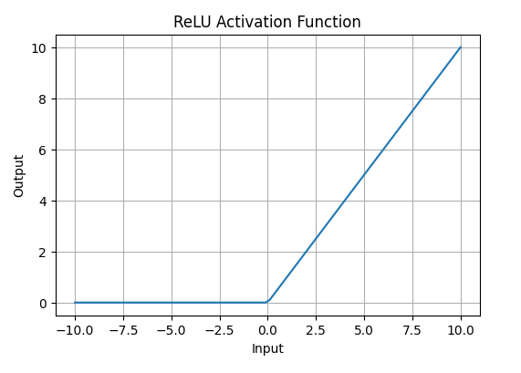

4. Leaky ReLU:
- Formula:
f(x)={xif x>0αxif x≤0f(x)={xαx​if x>0if x≤0​
Where α\alphaα is a small constant (e.g., 0.01).
- Range: (-∞, ∞)
- Properties:
  - Allows a small gradient when the input is negative, addressing the dying ReLU problem.
- Use Cases: Effective in training deep networks.

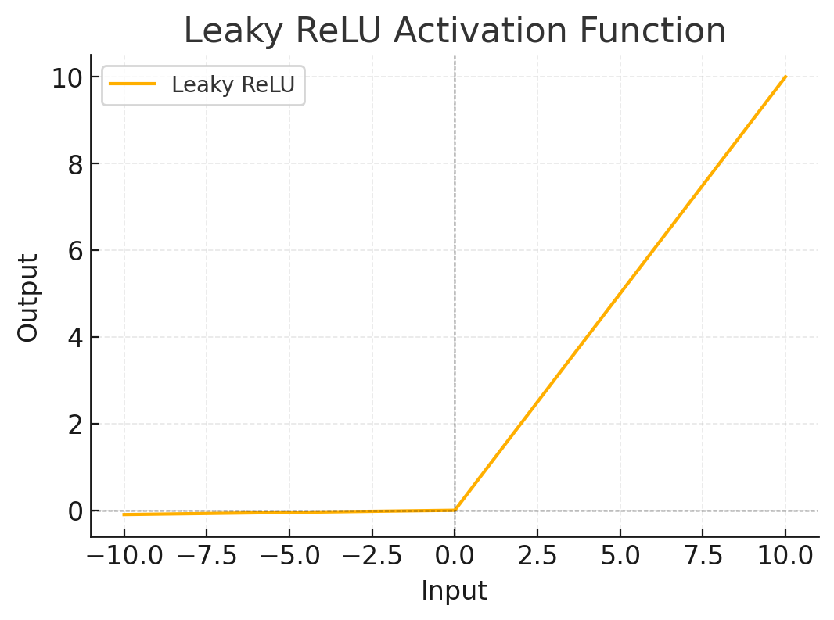

5. Softmax Function:
- Formula:
softmax(zi)=ezi∑j=1Kezjsoftmax(zi​)=∑j=1K​ezj​ezi​​
- Range: (0, 1)
- Properties:
  - Converts raw logits into probabilities, where the sum of the probabilities is 1.
- Use Cases: Commonly used in the output layer for multi-class classification problems.
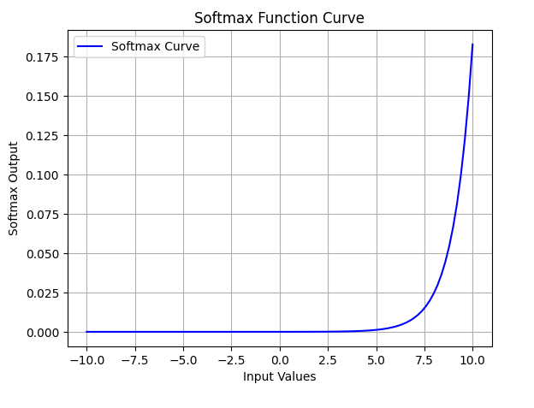

Choosing the Right Activation Function
- Problem Type: Choose activation functions based on whether the problem is binary (sigmoid) or multi-class (softmax).
- Layer Position: Use ReLU for hidden layers and softmax for the output layer in multi-class tasks.
- Avoiding Vanishing Gradients: Use ReLU or its variants (like leaky ReLU) in deep networks to minimize the vanishing gradient problem.

Introduction to Loss Functions
Loss functions quantify how well a neural network's predictions match the actual outcomes. They provide feedback that guides the training process, allowing the model to learn from its errors.
Types of Loss Functions
1. Mean Squared Error (MSE):
Mean Squared Error (MSE) is one of the most common loss functions for regression tasks. It calculates the average squared difference between the predicted values and the true values, making it highly sensitive to large errors.
Formula:
MSE=1n∑i=1n(yi−y^i)2MSE=n1​∑i=1n​(yi​−y^​i​)2
Code Implementation:
import numpy as np

def mean_squared_error(y_true, y_pred):
return np.mean((y_true - y_pred) ** 2)

# Example
y_true = np.array([3.0, -0.5, 2.0, 7.0])
y_pred = np.array([2.5, 0.0, 2.0, 8.0])

mse = mean_squared_error(y_true, y_pred)
print(f'Mean Squared Error: {mse}')
Use Case:
MSE is widely used in regression tasks, where you aim to minimize the difference between predicted and actual continuous values. It works well when outliers are meaningful, as it gives larger errors a higher penalty.
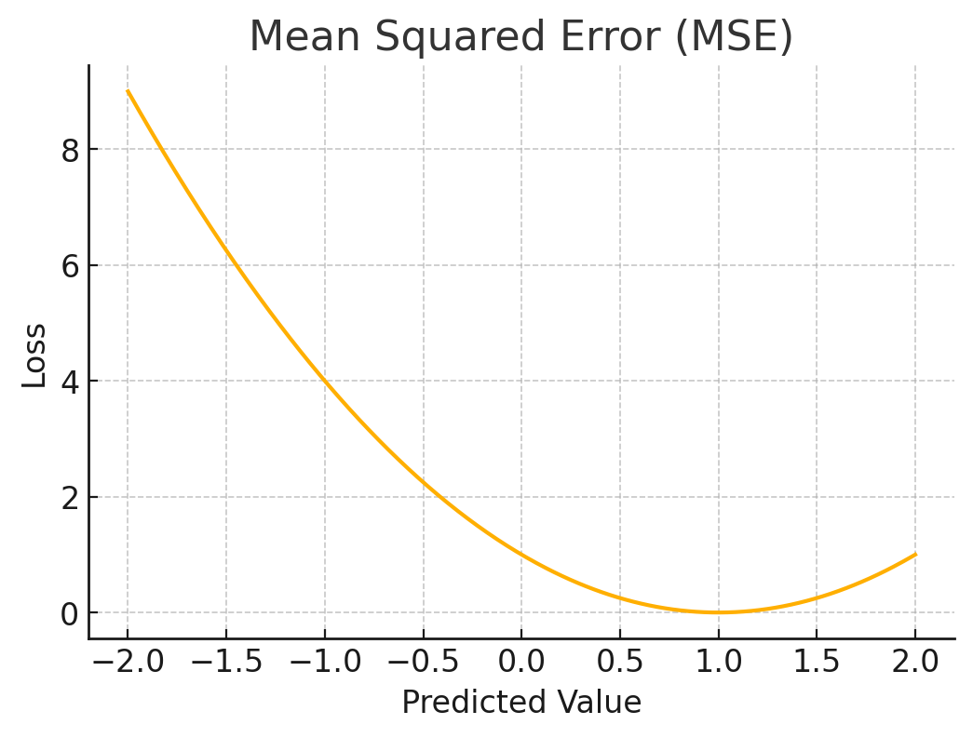
2. Mean Absolute Error (MAE)
Mean Absolute Error (MAE) is another common loss function for regression tasks. It measures the average of the absolute differences between predicted values and actual values, making it more robust to outliers than MSE.
Formula:
MAE=1n∑i=1n∣ytruei−ypredi∣MAE=n1​∑i=1n​∣ytruei​​−ypredi​​∣
Code Implementation:
def mean_absolute_error(y_true, y_pred):
return np.mean(np.abs(y_true - y_pred))

# Example
mae = mean_absolute_error(y_true, y_pred)
print(f'Mean Absolute Error: {mae}')
Use Case:
MAE is preferred when you want to treat all errors equally and reduce the effect of outliers. It’s useful in regression tasks where absolute error is a more meaningful measure than squared error.
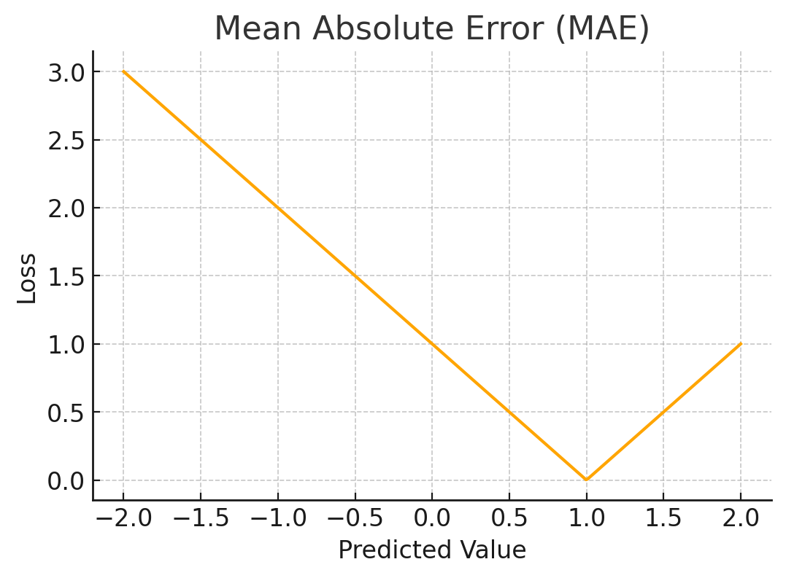

3. Huber Loss
Huber Loss combines both MSE and MAE, making it less sensitive to outliers than MSE and more stable than MAE. It behaves like MSE when the error is small and like MAE when the error is large.
Formula:
Lδ(a)={12a2if ∣a∣≤δ,δ(∣a∣−12δ)otherwise.Lδ​(a)={21​a2δ(∣a∣−21​δ)​if ∣a∣≤δ,otherwise.​
Code Implementation:
def huber_loss(y_true, y_pred, delta=1.0):
error = y_true - y_pred
is_small_error = np.abs(error) <= delta
squared_loss = 0.5 * np.square(error)
linear_loss = delta * (np.abs(error) - 0.5 * delta)
return np.mean(np.where(is_small_error, squared_loss, linear_loss))

# Example
huber = huber_loss(y_true, y_pred, delta=1.0)
print(f'Huber Loss: {huber}')
Use Case:
Huber loss is particularly useful for regression tasks with outliers. It balances between penalizing large errors and handling them without skewing the model's learning process.
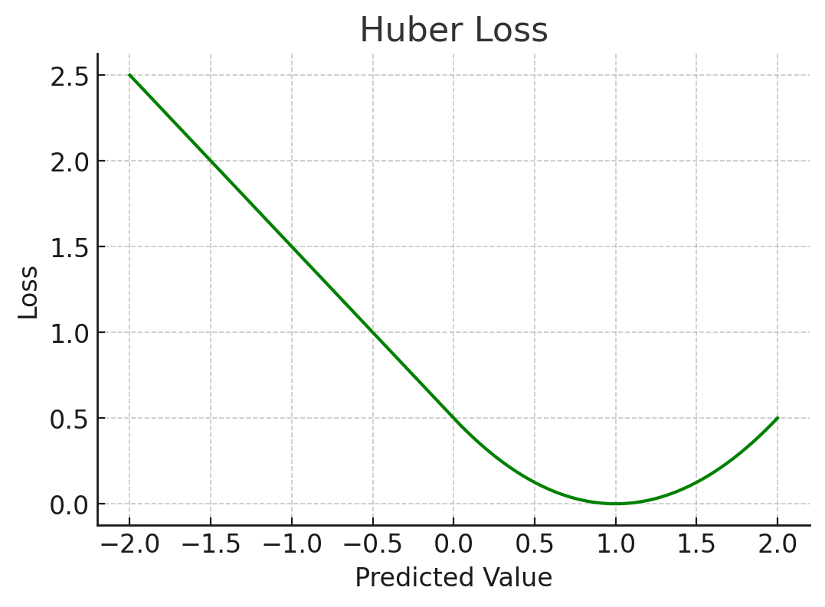

4. Binary Cross-Entropy Loss:
Binary Cross-Entropy Loss is used for binary classification problems. It measures the performance by comparing the predicted probability distribution with the actual binary labels.
Formula:
BCE=−1n∑i=1n[yilog⁡(y^i)+(1−yi)log⁡(1−y^i)]BCE=−n1​∑i=1n​[yi​log(y^​i​)+(1−yi​)log(1−y^​i​)]
Code Implementation:
def binary_cross_entropy(y_true, y_pred):
epsilon = 1e-15 # To prevent log(0)
y_pred = np.clip(y_pred, epsilon, 1 - epsilon)
return -np.mean(y_true * np.log(y_pred) + (1 - y_true) * np.log(1 - y_pred))

# Example
y_true_binary = np.array([1, 0, 1, 1])
y_pred_binary = np.array([0.9, 0.1, 0.8, 0.7])

binary_ce = binary_cross_entropy(y_true_binary, y_pred_binary)
print(f'Binary Cross-Entropy Loss: {binary_ce}')
Use Case:
Binary Cross-Entropy is the go-to loss function for binary classification tasks, such as determining whether an email is spam or not.
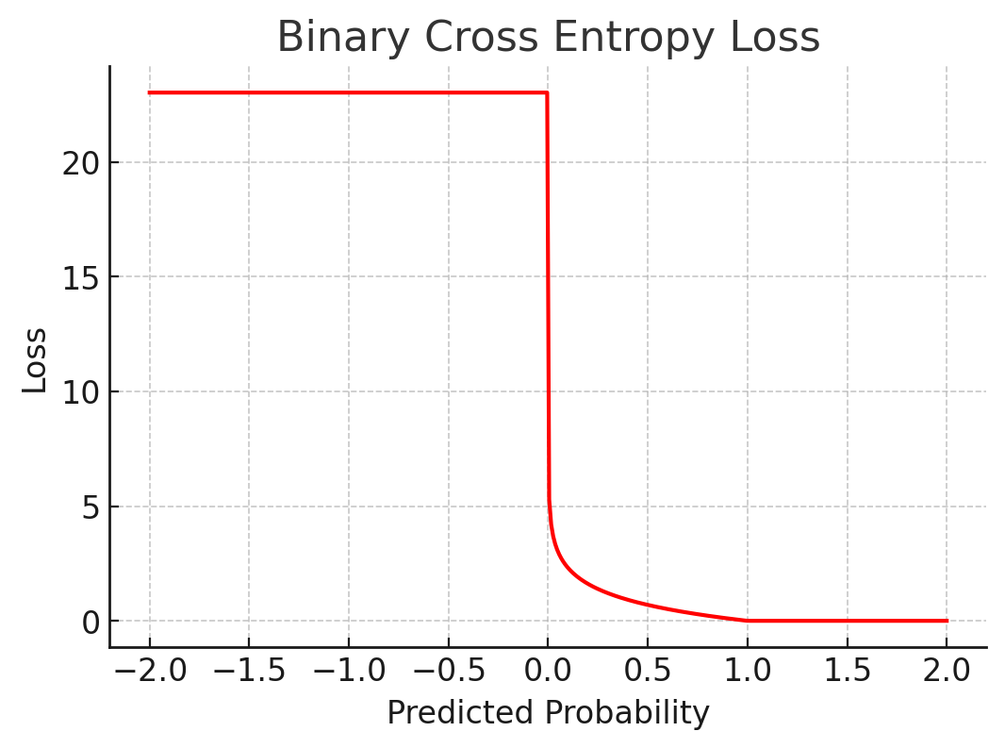

5. Categorical Cross-Entropy Loss:
Categorical Cross-Entropy Loss is used for multi-class classification problems, where the goal is to classify instances into more than two categories.
Formula:
CCE=−∑i=1Cyilog⁡(y^i)CCE=−∑i=1C​yi​log(y^​i​)
Code Implementation:
import tensorflow as tf

y_true_cat = [[1, 0, 0], [0, 1, 0], [0, 0, 1]]
y_pred_cat = [[0.9, 0.05, 0.05], [0.1, 0.8, 0.1], [0.05, 0.05, 0.9]]

# Using TensorFlow's built-in function
cat_ce = tf.keras.losses.categorical_crossentropy(y_true_cat, y_pred_cat)
print(f'Categorical Cross-Entropy Loss: {tf.reduce_mean(cat_ce).numpy()}')
Use Case:
This loss function is suitable for multi-class classification tasks, such as classifying an image into one of several categories.
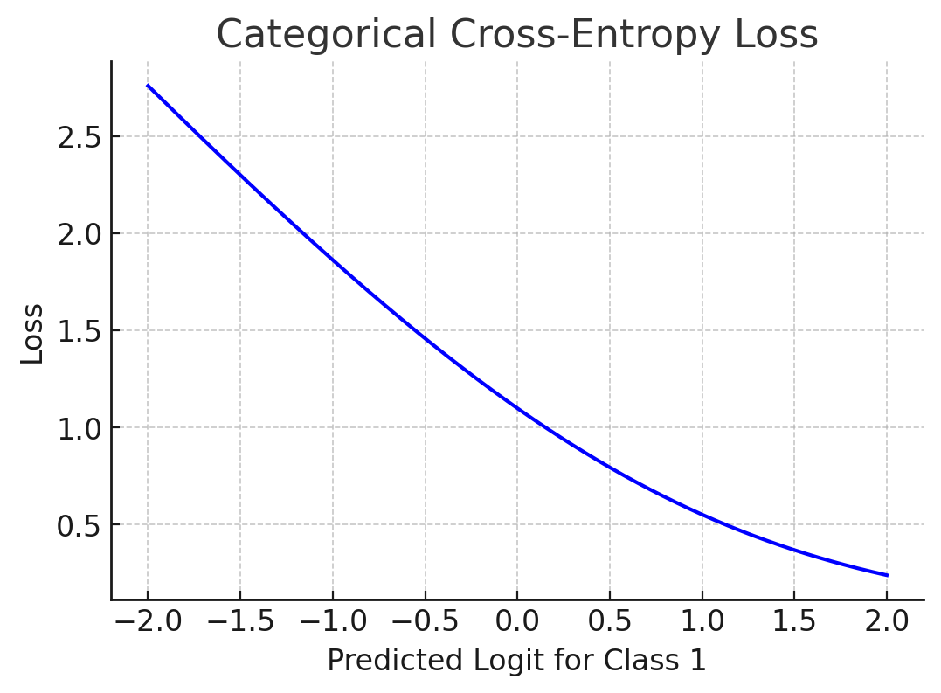

6. Hinge Loss:
Hinge Loss is commonly used in support vector machines (SVMs) for binary classification. It ensures a margin between the decision boundary and the data points. In essence, hinge loss penalizes misclassified data points and data points that are close to the decision boundary.
Formula:
Hinge=∑i=1nmax⁡(0,1−yi⋅y^i)Hinge=∑i=1n​max(0,1−yi​⋅y^​i​)
Code Implementation:
def hinge_loss(y_true, y_pred):
return np.mean(np.maximum(0, 1 - y_true * y_pred))

# Example
y_true_hinge = np.array([1, -1, 1, -1])
y_pred_hinge = np.array([0.8, -0.7, 0.9, -0.6])

hinge = hinge_loss(y_true_hinge, y_pred_hinge)
print(f'Hinge Loss: {hinge}')
Use Case:
Hinge loss is ideal for binary classification problems, particularly when using support vector machines (SVMs). It encourages the model to correctly classify data points while maximizing the margin between classes.
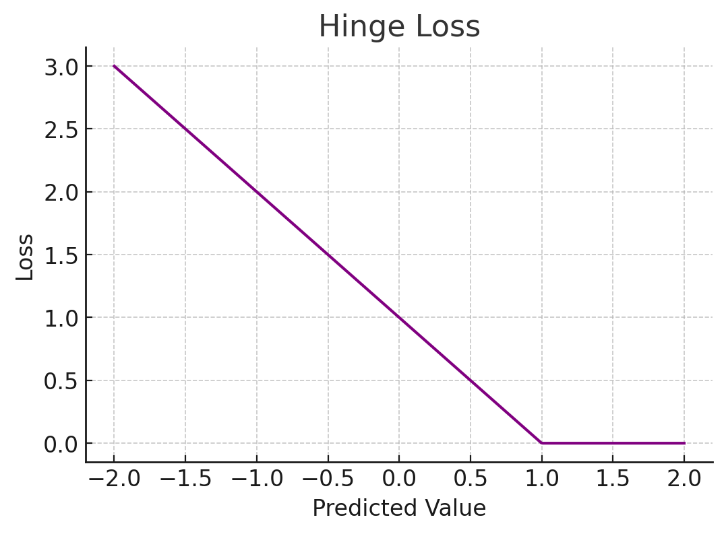

Introduction to Optimizers
When it comes to training machine learning models, optimization plays a key role in adjusting model parameters to minimize the error or loss. Optimization is the heart of machine learning algorithms, and without it, our models wouldn't learn effectively. In this article, we'll explore the most commonly used optimizers, their working mechanisms, and their strengths and weaknesses, so that you can better understand which one suits your project.
1. Gradient Descent
Gradient Descent is the most basic and widely used optimizer. The idea is simple: the algorithm iteratively updates the model's parameters by calculating the gradient (i.e., the slope) of the loss function with respect to the model parameters and moving in the direction of steepest descent to minimize the loss.
Types of Gradient Descent:
- Batch Gradient Descent: Uses the entire dataset to compute the gradient, which can be slow and computationally expensive for large datasets.
- Stochastic Gradient Descent (SGD): Instead of using the entire dataset, it updates the parameters after every single data point. While it’s faster, it may introduce more noise into the optimization.
- Mini-batch Gradient Descent: A mix of the two, this method uses a subset (mini-batch) of the data at each iteration, striking a balance between computation time and the stability of updates.
Pros:
- Simple to implement.
- Scales well with large datasets using Mini-batch Gradient Descent.
Cons:
- Can get stuck in local minima.
- Requires manual tuning of learning rate.
2. Momentum
Momentum builds on the idea of Gradient Descent but adds an additional term to the weight update that helps accelerate gradients vectors in the right direction. By doing so, it helps the optimizer avoid oscillations and converge faster.
The key idea here is to accumulate the velocity of the gradients from previous steps, thereby smoothing out the updates and making the optimization more efficient, especially when navigating around areas of high curvature.
Pros:
- Helps avoid local minima.
- Speeds up convergence.
Cons:
- Needs careful tuning of the momentum term.
3. Adagrad (Adaptive Gradient Algorithm)
Adagrad adjusts the learning rate dynamically based on the frequency of updates for each parameter. It scales the learning rate inversely proportional to the sum of all the historical gradients of the parameter. This means that frequently updated parameters receive smaller updates, while infrequent ones receive larger updates.
Pros:
- Suitable for sparse data (like NLP or recommendation systems).
- No need to tune the learning rate manually.
Cons:
- The learning rate can shrink too much over time, causing premature convergence.
4. RMSprop (Root Mean Square Propagation)
RMSprop is designed to solve the diminishing learning rate problem of Adagrad. It does so by using a moving average of squared gradients to normalize the gradient. This helps in keeping the learning rate from decaying too much over time and ensures more stable updates.
Pros:
- Performs well for online learning and non-stationary problems.
- Handles noisy gradients efficiently.
Cons:
- Requires tuning of hyperparameters, such as the decay rate.
5. Adam (Adaptive Moment Estimation)
Adam is one of the most popular optimizers in deep learning due to its robustness and efficiency. It combines the benefits of both Momentum and RMSprop by computing adaptive learning rates for each parameter using estimates of first (momentum) and second moments of the gradients.
Adam works well in most scenarios without much parameter tuning, making it the go-to optimizer for many deep learning models.
Pros:
- Works well in practice for most models.
- Adaptive learning rates for each parameter.
- Efficient for large datasets.
Cons:
- Computationally expensive compared to basic SGD.
- Requires fine-tuning of hyperparameters such as learning rate and beta values.
6. Nadam (Nesterov-accelerated Adaptive Moment Estimation)
Nadam is an extension of Adam that incorporates Nesterov momentum. Nesterov momentum slightly modifies the way momentum is computed by looking ahead at future gradients, thereby providing better speed and accuracy during optimization.
Pros:
- Faster convergence than Adam.
- More precise updates by utilizing Nesterov momentum.
Cons:
- Still computationally expensive and may not show significant improvement over Adam in every case.
Conclusion
Optimizers are essential tools for tuning the parameters of machine learning models, and each optimizer has its strengths and weaknesses. The right optimizer for your model depends on the problem you're solving, the size of the dataset, and the computational resources available.
- For beginners, Adam is often the best choice due to its versatility and efficiency.
- RMSprop is ideal for online learning and recurrent neural networks.
- If you are working with sparse data, Adagrad might give you a good performance.

Overview of Dataset Preparation
Dataset preparation encompasses:
- Loading and Understanding the Data: Identifying dataset characteristics.
- Preprocessing: Techniques like scaling, normalization, and reshaping.
- Data Splitting: Dividing data into training, validation, and test sets.
- Data Augmentation: Enhancing dataset variability to boost model robustness.
1. Loading and Understanding the Data
The MNIST dataset consists of grayscale images of handwritten digits (0–9), each represented by a 28x28 pixel matrix. The task is to classify each image into one of the 10 possible digit classes. This dataset is popular for demonstrating image classification concepts and is readily available in TensorFlow.
To begin, we load the dataset and inspect its structure.
import tensorflow as tf
import matplotlib.pyplot as plt

# Load the MNIST dataset
(train_images, train_labels), (test_images, test_labels) = tf.keras.datasets.mnist.load_data()

# Inspect data shape
print(f"Training data shape: {train_images.shape}, Training labels shape: {train_labels.shape}")
print(f"Test data shape: {test_images.shape}, Test labels shape: {test_labels.shape}")

# Visualize a sample image
plt.imshow(train_images[0], cmap='gray')
plt.title(f"Label: {train_labels[0]}")
plt.show()
Explanation: Loading the dataset allows us to verify its structure and visualize a sample to confirm that it’s in the expected format. This inspection shows that we have 60,000 training images and 10,000 test images, each with a label from 0 to 9.
Output:
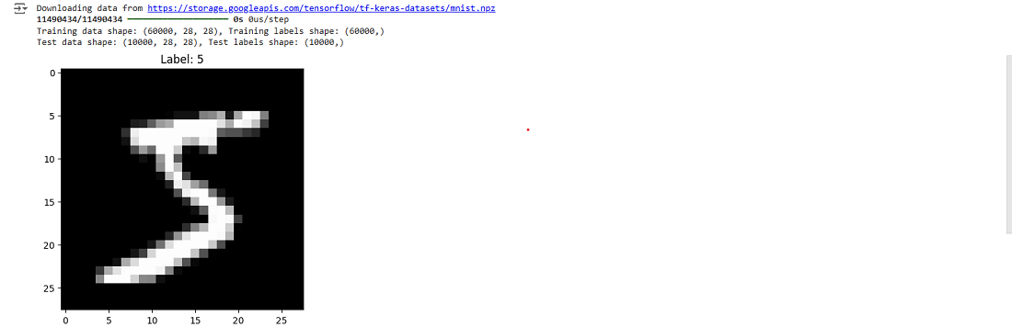

2. Preprocessing: Normalization and Scaling
In raw form, pixel values in images range from 0 to 255, which can lead to large gradient updates during training, slowing convergence. To make the model training process more efficient, we normalize the pixel values to a range of [0, 1].
# Normalize pixel values
train_images, test_images = train_images / 255.0, test_images / 255.0
Explanation: Scaling pixel values down to a range of [0, 1] helps reduce the impact of high values, stabilizing the gradient descent process. This transformation allows the model to converge more reliably and avoids saturation in neurons, which can occur when values are too high.
3. Splitting Data for Training, Validation, and Testing
A good model should be able to generalize to unseen data. We divide the dataset into three subsets:
- Training set: Used to train the model.
- Validation set: Used to tune hyperparameters and check for overfitting.
- Test set: Used to evaluate the final model’s performance.
from sklearn.model_selection import train_test_split

# Split the training data further for validation
train_images, val_images, train_labels, val_labels = train_test_split(
train_images, train_labels, test_size=0.2, random_state=42
)
Explanation: Using an 80-20 split, we reserve a portion of the training data as the validation set. This helps us monitor the model’s performance on unseen data during training, preventing overfitting.
4. Data Augmentation (Optional)
Data augmentation creates new, slightly altered versions of images by applying transformations like rotations, shifts, and flips. This artificially increases dataset diversity, helping the model generalize better.
from tensorflow.keras.preprocessing.image import ImageDataGenerator

# Set up image data generator with augmentation
datagen = ImageDataGenerator(
rotation_range=10,
zoom_range=0.1,
width_shift_range=0.1,
height_shift_range=0.1
)
datagen.fit(train_images.reshape(-1, 28, 28, 1)) # Reshape for compatibility
Explanation: Data augmentation increases the dataset's variability, which helps the model learn more robust features, especially for smaller datasets.

Model Architecture

Introduction
The model architecture defines the structure of a neural network, specifying how data flows from input to output and the transformations applied at each layer. This article covers the theory and practical design of a simple neural network for classifying the MNIST handwritten digits dataset.
Overview of Model Architecture
- Layer Types: Understanding dense layers, activation functions, and output layers.
- Building the Model: Defining layers for a simple classification task.
- Compiling the Model: Specifying the optimizer, loss function, and evaluation metrics.
1. Layer Types
A neural network consists of several types of layers, each with a specific role:
- Flatten Layer: The Flatten layer is primarily used in CNNs (Convolutional Neural Networks) to bridge the gap between the convolutional layers and the fully connected layers. It converts multi-dimensional arrays (such as 2D image arrays) into 1D arrays that can be fed into Dense (Fully Connected) layers. By "flattening" an image, each pixel is treated as an individual feature, making it easier to pass the data into a standard neural network layer for classification or regression tasks.
- Dense Layer (Fully Connected Layer): The Dense layer is also known as the Fully Connected (FC) layer, as every neuron in the layer is connected to every neuron in the previous layer. Dense layers perform complex transformations on the inputs, allowing the model to learn higher-order features. Each connection has a weight that is adjusted during training, enabling the network to learn which features are most relevant to the task at hand.
- Activation Functions: Activation functions introduce non-linearity into the network, enabling it to capture complex patterns in the data. Without activation functions, the network would essentially be a series of linear transformations, limiting its ability to handle non-linear relationships.
For this task, we’ll use:
- A Flatten layer to prepare the image for a dense layer.
- A Dense hidden layer with ReLU activation for non-linearity.
- An Output layer with softmax activation for probability output across 10 classes.
2. Building the Model
We use TensorFlow’s Sequential API to define our layers in a straightforward, layer-by-layer manner.
import tensorflow as tf

# Define the model architecture
model = tf.keras.Sequential([
tf.keras.layers.Flatten(input_shape=(28, 28)), # Flatten layer
tf.keras.layers.Dense(128, activation='relu'), # Hidden dense layer with ReLU
tf.keras.layers.Dense(10, activation='softmax') # Output dense layer with softmax
])
Explanation: This architecture flattens the 28x28 input image to a vector of 784 features, which feeds into a hidden dense layer with 128 neurons. The ReLU activation introduces non-linearity. Finally, the output layer with 10 neurons and softmax activation provides probabilities for each class (0-9).
3. Compiling the Model
Compiling a model defines the learning process. We specify:
- Optimizer: The optimizer is an algorithm that updates the weights of a neural network to minimize the loss function, which quantifies prediction error. By iteratively adjusting weights in the direction that reduces error (based on calculated gradients), the optimizer drives the model closer to optimal performance.
- Loss Function: The loss function is a key component that guides the optimizer in adjusting weights. It measures the difference between the model’s predictions and the actual values, providing a single value that represents the model’s prediction error. Lower loss values indicate better performance, as they suggest the model's predictions are closer to the ground truth.
- Metrics: Metrics evaluate model performance throughout training and after deployment, providing insight into how well the model generalizes to new data. Unlike the loss function, which serves primarily to optimize weights, metrics give a more interpretable measure of model performance. Metrics do not directly influence the weight updates but instead track training progress and final model effectiveness.
model.compile(optimizer='adam',
loss='sparse_categorical_crossentropy',
metrics=['accuracy'])
Explanation: Adam is an adaptive optimizer suitable for large networks. Sparse categorical crossentropy is ideal for integer labels in multiclass classification. Accuracy is a common metric for classification tasks.

Training and Evaluation

Introduction
Training and evaluation are the heart of model development. Training enables a model to learn from data, while evaluation measures its effectiveness. This article explains the steps involved in training and evaluating a neural network on the MNIST dataset.
Overview of Training and Evaluation
- The Training Process: Using the fit method.
- Monitoring Training and Validation Metrics: Detecting overfitting.
- Testing the Model on Unseen Data: Evaluating generalization.1. The Training Process
1. The Training Process
Training adjusts the model’s parameters to minimize the loss function. Each epoch represents a full pass over the dataset, while the batch size specifies how many samples are used to update weights in each iteration.
# Train the model
history = model.fit(train_images, train_labels, epochs=10, validation_data=(val_images, val_labels))
Explanation: Here, we use epochs=10, which means the model will go through the dataset 10 times. The validation data helps monitor performance on unseen data during training, preventing overfitting.
2. Monitoring Training and Validation Metrics
Visualizing accuracy and loss helps us understand how well the model is learning. If training accuracy increases but validation accuracy plateaus, overfitting may be occurring.
import matplotlib.pyplot as plt

# Plot accuracy over epochs
# Plot training accuracy from the history data over each epoch
plt.plot(history.history['accuracy'], label='Training Accuracy')

# Plot validation accuracy from the history data over each epoch
plt.plot(history.history['val_accuracy'], label='Validation Accuracy')

# Set the title of the plot to indicate it's showing accuracy metrics
plt.title('Model Accuracy')

# Label the x-axis as 'Epoch' to represent training cycles
plt.xlabel('Epoch')

# Label the y-axis as 'Accuracy' to represent the accuracy score
plt.ylabel('Accuracy')

# Display the legend to distinguish between training and validation accuracy
plt.legend()

# Display the plot
plt.show()

# Plot loss over epochs
# Plot training loss from the history data over each epoch
plt.plot(history.history['loss'], label='Training Loss')

# Plot validation loss from the history data over each epoch
plt.plot(history.history['val_loss'], label='Validation Loss')

# Set the title of the plot to indicate it's showing loss metrics
plt.title('Model Loss')

# Label the x-axis as 'Epoch' to represent training cycles
plt.xlabel('Epoch')

# Label the y-axis as 'Loss' to represent the loss score
plt.ylabel('Loss')

# Display the legend to distinguish between training and validation loss
plt.legend()

# Display the plot
plt.show()
Explanation: By plotting training and validation metrics, we can detect if the model is overfitting or underfitting, allowing adjustments as needed.
Output:
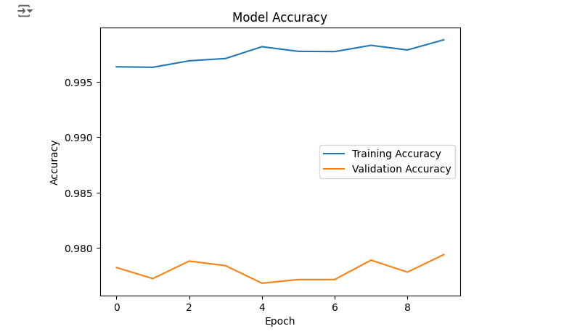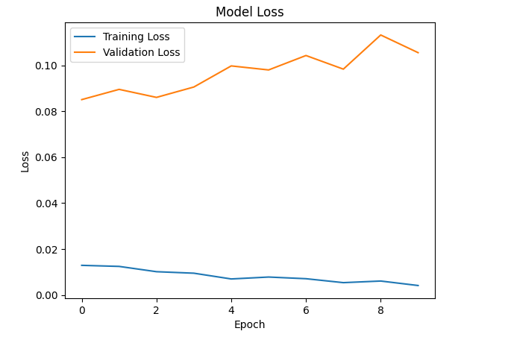

3. Testing the Model on Unseen Data
After training, we evaluate the model’s generalization on the test set, providing an unbiased measure of performance.
# Evaluate on test data
test_loss, test_accuracy = model.evaluate(test_images, test_labels)
print(f"Test Accuracy: {test_accuracy:.4f}")
Explanation: High test accuracy indicates that the model has learned to generalize well beyond the training data.
Ouput:

What is Convolution?
Convolution is a mathematical operation used to combine two functions, typically an input signal and a filter (or kernel), to produce a modified output. In the context of image processing and CNNs, convolution helps in detecting patterns such as edges, textures, and shapes within images.
Key Points:
- Convolution emphasizes important features while suppressing irrelevant information.
- It preserves the spatial relationship between pixels, which is crucial for image analysis.
Convolution Operation Explained
In image processing, convolution involves sliding a filter over the input image and computing the dot product between the filter and the overlapping region of the image.
Mathematical Representation:
For a 2D image I and a filter K, the convolution S at position (i,j) is given by:
S(i,j)=∑m∑nI(i+m,j+n)⋅K(m,n)S(i,j)=∑m​∑n​I(i+m,j+n)⋅K(m,n)
Where:
- m,n, iterate over the dimensions of the filter.
- i,j are the coordinates on the input image.
Example:
Consider a 3x3 image and a 2x2 filter:
I=[123456789],K=[100−1]I=[123456789],K=[100−1]
The convolution operation will produce a new matrix by sliding K over I and computing the dot products.
Kernels (Filters) and Feature Maps
Kernels are small matrices used to detect specific features in the input data. Multiple kernels can be applied to an input image to generate feature maps, each highlighting different aspects of the image.
Types of Kernels:
- Edge Detection: Identifies edges within the image.
- Sharpening: Enhances the contrast between adjacent pixels.
- Blurring: Smoothens the image by averaging pixel values.
Feature Maps: Each feature map corresponds to a specific kernel and captures the presence of particular features in the input image. Stacking multiple feature maps allows the network to learn complex and hierarchical representations.
Stride and Padding
Stride and padding are hyperparameters that control the movement of the filter and the size of the output feature map.
- Stride: The number of pixels the filter moves across the image. A stride of 1 moves the filter one pixel at a time, while a stride of 2 skips every other pixel.
- Padding: Adding extra pixels around the input image to control the spatial dimensions of the output. Common padding types include:
  - Valid Padding: No padding. Output size decreases.
  - Same Padding: Pads the input to maintain the output size equal to the input size.
Impact on Output Dimensions:
Output Size=W−F+2PS+1Output Size=SW−F+2P​+1
Where:
- W = Input width
- F = Filter size
- P= Padding
- S = Stride
Advantages of Convolutions in Neural Networks
- Parameter Sharing: Reduces the number of parameters by using the same filter across different regions of the input, enhancing computational efficiency.
- Local Connectivity: Focuses on local regions of the input, allowing the network to capture spatial hierarchies of features.
- Translation Invariance: Ensures that the network recognizes features regardless of their position in the input.
Practical Implementation with TensorFlow
Let's implement a convolution operation using TensorFlow's Keras API to solidify our understanding.
Step 1: Import Libraries
import tensorflow as tf
import numpy as np
import matplotlib.pyplot as plt
Step 2: Create a Sample Image
For demonstration, we'll create a simple 5x5 grayscale image.
# Sample image: 5x5 pixels
sample_image = np.array([
[1, 2, 3, 0, 0],
[4, 5, 6, 0, 0],
[7, 8, 9, 0, 0],
[0, 0, 0, 1, 2],
[0, 0, 0, 3, 4]
], dtype=np.float32)

# Reshape to match TensorFlow's expected input shape: (batch_size, height, width, channels)
sample_image = sample_image.reshape((1, 5, 5, 1))
Step 3: Define a Convolutional Layer
We'll define a convolutional layer with a single filter for simplicity.
# Import TensorFlow library
import tensorflow as tf

# Define a 2D Convolutional layer with specific properties
conv_layer = tf.keras.layers.Conv2D(
filters=1, # Number of filters (1 in this case, often for grayscale single feature output)
kernel_size=(3, 3), # Size of each filter (3x3 kernel)
strides=(1, 1), # Step size for the convolution, moving 1 pixel at a time in both dimensions
padding='valid', # No padding, so the output size will be smaller than the input
activation='relu', # Activation function applied to the output; ReLU sets negative values to 0
kernel_initializer=tf.constant_initializer([[1, 0, -1],
[1, 0, -1],
[1, 0, -1]]), # Initialize kernel with edge-detection-like values
bias_initializer='zeros' # Initialize the bias term as zeros
)
Step 4: Apply Convolution
# Apply convolution
output = conv_layer(sample_image)

# Remove batch and channel dimensions for visualization
output_image = output.numpy().squeeze()

print("Output after convolution:")
print(output_image)
Output:
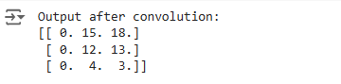

Output Explanation:
The convolution operation applies the defined filter to the input image, producing a feature map that highlights vertical edges due to the filter's structure.
Step 5: Visualize the Output
# Create a figure with 1 row and 2 columns for side-by-side comparison of images
fig, axs = plt.subplots(1, 2, figsize=(8, 4))

# Display the Original Image
axs[0].imshow(sample_image.squeeze(), cmap='gray') # Show the original image in grayscale
axs[0].set_title('Original Image') # Set title for the original image
axs[0].axis('off') # Hide axes for a cleaner look

# Display the Feature Map (Output Image after Convolution)
axs[1].imshow(output_image, cmap='gray') # Show the result of convolution in grayscale
axs[1].set_title('After Convolution') # Set title for the convolution result
axs[1].axis('off') # Hide axes for a cleaner look

# Show the complete visualization with both images side by side
plt.show()
Output:
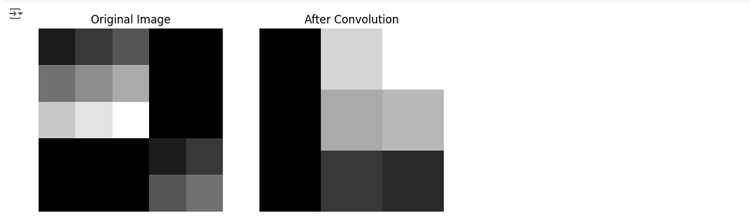

Note: The visualization will show the original image alongside the feature map resulting from the convolution operation.

1. What are Pooling Layers?
Pooling layers are a type of layer in CNNs that perform downsampling on feature maps. The primary purpose is to reduce the spatial dimensions (width and height) while retaining the most critical information, thereby enhancing computational efficiency and mitigating overfitting.
Key Functions:
- Dimensionality Reduction: Decreases the number of parameters and computations in the network.
- Translation Invariance: Helps the network recognize features regardless of their position in the input.
- Noise Suppression: Reduces the impact of noise and minor variations in the input.
2. Types of Pooling
There are several pooling strategies, each with its unique approach to downsampling:
a. Max Pooling
Max Pooling selects the maximum value within a specified window (pool size) as it slides over the input feature map.
Advantages:
- Captures the most prominent features.
- Effective in highlighting high-activation areas, such as edges.
Example:
Consider a 2x2 max pooling operation on the following feature map:
[1324][12​34​]
Result: 4 (the maximum value)
b. Average Pooling
Average Pooling computes the average of all values within the pooling window.
Advantages:
- Provides a smoother representation by averaging features.
- Less sensitive to the exact location of features compared to max pooling.
Example:
Using the same 2x2 window:
[1324][12​34​]
Result: (1+3+2+4)/4 =2.5
c. Global Pooling
Global Pooling reduces each feature map to a single value by applying a pooling operation across the entire spatial dimension.
- Global Max Pooling: Selects the maximum value in the entire feature map.
- Global Average Pooling: Computes the average of all values in the feature map.
Use Cases:
- Often used just before the output layer to create a fixed-size output, regardless of input dimensions.
- Helps in reducing overfitting by minimizing the number of parameters.
3. Parameters: Pool Size and Stride
Pool Size: The dimensions of the window (e.g., 2x2, 3x3) over which the pooling operation is performed.
Stride: The number of pixels the pooling window moves across the input feature map.
Impact on Output Dimensions:
Output Size=W−FS+1Output Size=SW−F​+1
Where:
- W = Input size
- F = Pool size
- S = Stride
Choosing Pool Size and Stride:
- Common Choices: Pool size of 2x2 with a stride of 2.
- Effect: Halves the spatial dimensions, effectively reducing the number of parameters by a factor of four.
4. Advantages of Pooling Layers
- Computational Efficiency: Reduces the number of parameters and computations in subsequent layers.
- Robustness: Enhances the network’s ability to recognize features regardless of their position, scale, or orientation.
- Overfitting Control: Limits the capacity of the network, preventing it from learning noise in the data.
5. Pooling vs. Convolution
Feature | Convolution | Pooling
Purpose | Extracts features like edges, textures, and shapes | Reduces spatial size, decreases parameters, and retains essential features
Operation | Applies a filter for element-wise multiplication and summing | Takes maximum or average values in specified regions
output | Produces feature maps with highlighted patterns | Produces down-sampled feature maps
Types | Various filters for edge detection, blurring, etc. | Max Pooling, Average Pooling
Key Parameters | Filter size, stride, padding | Window size, stride
Effect on Image | Keeps spatial resolution intact, highlighting key features | Reduces spatial resolution, focusing on essential features only
Role in CNNs | Captures important patterns at different levels | Reduces computational complexity, adds translation invariance
6. Visualizing Pooling Operations
Visual representations can clarify how pooling operates on feature maps.
Original Feature Map (4x4):
[13245678910111213141516]⎣⎡​15913​361014​271115​481216​⎦⎤​
2x2 Max Pooling with Stride 2:
- First Window (Top-Left): Max(1, 3, 5, 6) = 6
- Second Window (Top-Right): Max(2, 4, 7, 8) = 8
- Third Window (Bottom-Left): Max(9, 10, 13, 14) = 14
- Fourth Window (Bottom-Right): Max(11, 12, 15, 16) = 16
Resulting Feature Map:
[681416][614​816​]
7. Practical Implementation with TensorFlow
Let's implement different pooling layers using TensorFlow's Keras API to understand their effects.
Step 1: Import Libraries
import tensorflow as tf
import numpy as np
import matplotlib.pyplot as plt
Step 2: Create a Sample Feature Map
We'll create a simple 4x4 feature map for demonstration.
# Sample feature map: 4x4
feature_map = np.array([
[1, 3, 2, 4],
[5, 6, 7, 8],
[9, 10, 11, 12],
[13, 14, 15, 16]
], dtype=np.float32)

# Reshape to match TensorFlow's expected input shape: (batch_size, height, width, channels)
feature_map = feature_map.reshape((1, 4, 4, 1))
Step 3: Define Pooling Layers
We'll define max pooling, average pooling, and global max pooling layers.
# Max Pooling
max_pool = tf.keras.layers.MaxPooling2D(pool_size=(2, 2), strides=2, padding='valid')

# Average Pooling
avg_pool = tf.keras.layers.AveragePooling2D(pool_size=(2, 2), strides=2, padding='valid')

# Global Max Pooling
global_max_pool = tf.keras.layers.GlobalMaxPooling2D()

# Global Average Pooling
global_avg_pool = tf.keras.layers.GlobalAveragePooling2D()
Step 4: Apply Pooling Operations
# Apply Max Pooling
max_pooled = max_pool(feature_map).numpy().squeeze()
print("Max Pooled Feature Map:\n", max_pooled)

# Apply Average Pooling
avg_pooled = avg_pool(feature_map).numpy().squeeze()
print("\nAverage Pooled Feature Map:\n", avg_pooled)

# Apply Global Max Pooling
global_max_pooled = global_max_pool(feature_map).numpy()
print("\nGlobal Max Pooled Feature Map:", global_max_pooled)

# Apply Global Average Pooling
global_avg_pooled = global_avg_pool(feature_map).numpy()
print("Global Average Pooled Feature Map:", global_avg_pooled)
Output:
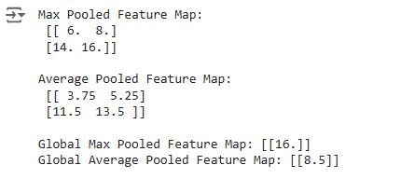
Output Explanation:
- Max Pooling: Extracts the maximum value from each 2x2 window.
- Average Pooling: Computes the average of each 2x2 window.
- Global Max Pooling: Selects the maximum value across the entire feature map.
- Global Average Pooling: Computes the average of all values in the feature map.
Step 5: Visualize the Results
# Original Feature Map
fig, axs = plt.subplots(1, 5, figsize=(20, 4))

# Remove .numpy() as feature_map is already a numpy array
axs[0].imshow(feature_map.squeeze(), cmap='gray', vmin=0, vmax=16)
axs[0].set_title('Original Feature Map')
axs[0].axis('off')

# Max Pooled
axs[1].imshow(max_pooled, cmap='gray', vmin=0, vmax=16)
axs[1].set_title('Max Pooling')
axs[1].axis('off')

# Average Pooled
axs[2].imshow(avg_pooled, cmap='gray', vmin=0, vmax=16)
axs[2].set_title('Average Pooling')
axs[2].axis('off')

# Global Max Pooled
# Reshape global_max_pooled to (1, 1) for imshow
axs[3].imshow(global_max_pooled.reshape(1, 1), cmap='gray', vmin=0, vmax=16)
axs[3].set_title('Global Max Pooling')
axs[3].axis('off')

# Global Average Pooled
# Reshape global_avg_pooled to (1, 1) for imshow
axs[4].imshow(global_avg_pooled.reshape(1, 1), cmap='gray', vmin=0, vmax=16)
axs[4].set_title('Global Average Pooling')
axs[4].axis('off')

plt.show()
Output:
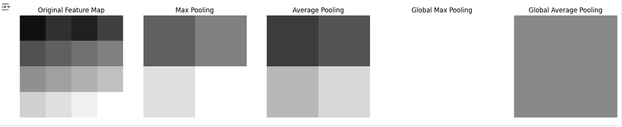

Note: Since global pooling results in a single value, we visualize them as 1x1 images.
Sure! Here's a clear explanation of the key concepts in Convolutional Neural Networks (CNNs):

🧠 What is a Convolutional Neural Network (CNN)?
CNN is a type of neural network primarily used for processing images, though it’s also useful for video, audio, and even text.
It mimics how our eyes/brain perceive visual patterns — by detecting edges, shapes, textures, and objects.

🔹 1. Kernel (or Filter)
➤ What it is:
A small matrix of numbers (e.g., 3x3 or 5x5) used to scan through the image.
➤ What it does:
Performs convolution, i.e., it slides over the image and multiplies values to extract features like edges, corners, colors, etc.
Example:
Kernel (3x3):
[[-1, 0, 1],
[-1, 0, 1],
[-1, 0, 1]]
This is a Sobel filter used to detect vertical edges.

🔹 2. Convolution Operation
➤ What it is:
Applying a kernel (filter) over an image (or feature map) by sliding it across and computing dot products.
➤ Purpose:
To highlight patterns like edges, lines, textures, etc.
Example:
Imagine a 5x5 image being scanned by a 3x3 kernel — the result is a smaller image (feature map) with highlighted features.

🔹 3. Feature Map (or Activation Map)
➤ What it is:
The output of the convolution operation.
➤ What it does:
Shows where in the image a specific pattern (e.g., edge) was detected.
➤ Why it matters:
Multiple feature maps (from different kernels) let the model learn different features — one detects edges, another detects curves, another detects color gradients, etc.

🔹 4. Pooling (e.g., Max Pooling, Average Pooling)
➤ What it is:
A downsampling technique to reduce the size of feature maps.
➤ Types:
- Max Pooling: Keeps the maximum value in a region.
- Average Pooling: Takes the average value.
➤ Why it's used:
- Reduces computation
- Makes model less sensitive to small shifts/variations
- Helps in extracting dominant features
Example:
2x2 Max Pooling:
[1, 3]
[4, 2] → max is 4

💡 Simple Analogy
Imagine a security scanner:
- The kernel is like a mini detector (e.g., metal detector wand).
- The convolution is scanning the whole body (image).
- The feature map is the signal showing where suspicious items are detected.
- Pooling is compressing that scan into key points to quickly make decisions.

🔁 Flow in CNN
- Input Image
- → Apply Kernels via Convolution
- → Get Feature Maps
- → Apply Pooling
- → Repeat (More Layers)
- → Flatten and pass to Dense Layers
- → Output (e.g., class: cat/dog)

If you want, I can show you this visually or walk you through the code of a basic CNN in TensorFlow/Keras.
Would you like that?
Implementing a CNN for Image Classification

Introduction
Convolutional Neural Networks (CNNs) have become the de facto standard for image classification tasks, owing to their ability to automatically and adaptively learn spatial hierarchies of features. This article guides you through the process of building a CNN for image classification using TensorFlow and Keras. We will cover the entire pipeline from data preparation and model architecture design to training, evaluation, and deployment.
1. Overview of CNNs for Image Classification
CNNs are specialized neural networks designed to process data with grid-like topology, such as images. Their architecture leverages local connectivity, parameter sharing, and hierarchical feature learning to efficiently recognize patterns and classify images.
Key Components of CNNs:
- Convolutional Layers: Extract spatial features using filters.
- Pooling Layers: Downsample feature maps to reduce dimensionality.
- Fully Connected Layers: Perform high-level reasoning based on extracted features.
- Activation Functions: Introduce non-linearity, enabling the network to learn complex patterns.
Applications:
- Object Detection
- Facial Recognition
- Medical Image Analysis
- Autonomous Vehicles
2. Dataset Selection and Preparation
For this implementation, we'll use the CIFAR-10 dataset, a widely used benchmark for image classification tasks. CIFAR-10 consists of 60,000 32x32 color images across 10 classes, with 6,000 images per class.
Classes:
- Airplane
- Automobile
- Bird
- Cat
- Deer
- Dog
- Frog
- Horse
- Ship
- Truck
Steps for Data Preparation:
- Loading the Dataset: TensorFlow provides direct access to CIFAR-10 via its Keras API.
- Data Normalization: Scale pixel values from [0, 255] to [0, 1] to facilitate faster convergence during training.
- One-Hot Encoding Labels: Convert integer labels to categorical format suitable for multi-class classification.
Code Implementation:
import tensorflow as tf
from tensorflow.keras.utils import to_categorical
import matplotlib.pyplot as plt

# Load CIFAR-10 dataset
(train_images, train_labels), (test_images, test_labels) = tf.keras.datasets.cifar10.load_data()

# Normalize pixel values
train_images = train_images.astype('float32') / 255.0
test_images = test_images.astype('float32') / 255.0

# One-hot encode labels
train_labels = to_categorical(train_labels, 10)
test_labels = to_categorical(test_labels, 10)

# Verify the data
print(f"Training data shape: {train_images.shape}, Training labels shape: {train_labels.shape}")
print(f"Test data shape: {test_images.shape}, Test labels shape: {test_labels.shape}")

# Visualize a sample image
plt.imshow(train_images[0])
plt.title("Sample Image - Class: " + str(tf.argmax(train_labels[0]).numpy()))
plt.axis('off')
plt.show()
Output:
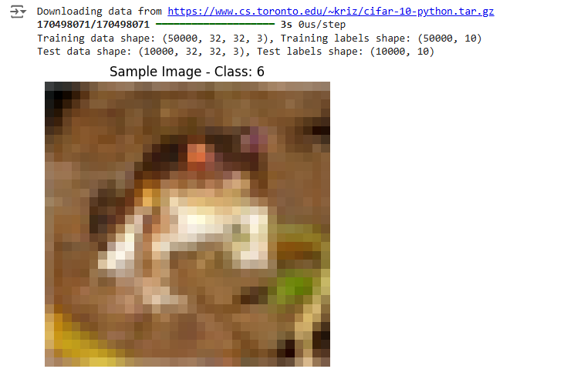
Explanation:
- Normalization: Scaling pixel values helps in stabilizing and accelerating the training process.
- One-Hot Encoding: Transforms labels into a binary matrix representation, making them compatible with categorical loss functions.
3. Designing the CNN Architecture
A typical CNN architecture for image classification involves stacking multiple convolutional and pooling layers, followed by fully connected layers. Below is a breakdown of a sample architecture suitable for CIFAR-10:
- Input Layer: Accepts input images of shape (32, 32, 3).
- Convolutional Layer 1:
  - Filters: 32
  - Kernel Size: (3, 3)
  - Activation: ReLU
  - Padding: Same
- Pooling Layer 1:
  - Type: Max Pooling
  - Pool Size: (2, 2)
  - Strides: 2
- Convolutional Layer 2:
  - Filters: 64
  - Kernel Size: (3, 3)
  - Activation: ReLU
  - Padding: Same
- Pooling Layer 2:
  - Type: Max Pooling
  - Pool Size: (2, 2)
  - Strides: 2
- Convolutional Layer 3:
  - Filters: 128
  - Kernel Size: (3, 3)
  - Activation: ReLU
  - Padding: Same
- Pooling Layer 3:
  - Type: Max Pooling
  - Pool Size: (2, 2)
  - Strides: 2
- Flatten Layer: Converts 3D feature maps to 1D feature vectors.
- Fully Connected Layer 1:
  - Units: 128
  - Activation: ReLU
- Dropout Layer:
  - Rate: 0.5
- Output Layer:
  - Units: 10
  - Activation: Softmax
Code Implementation:
from tensorflow.keras import layers, models

# Define the CNN architecture
def create_cnn_model():
model = models.Sequential()

# Convolutional Layer 1
model.add(layers.Conv2D(32, (3, 3), activation='relu', padding='same', input_shape=(32, 32, 3)))
# Pooling Layer 1
model.add(layers.MaxPooling2D((2, 2), strides=2))

# Convolutional Layer 2
model.add(layers.Conv2D(64, (3, 3), activation='relu', padding='same'))
# Pooling Layer 2
model.add(layers.MaxPooling2D((2, 2), strides=2))

# Convolutional Layer 3
model.add(layers.Conv2D(128, (3, 3), activation='relu', padding='same'))
# Pooling Layer 3
model.add(layers.MaxPooling2D((2, 2), strides=2))

# Flatten Layer
model.add(layers.Flatten())

# Fully Connected Layer 1
model.add(layers.Dense(128, activation='relu'))

# Dropout Layer
model.add(layers.Dropout(0.5))

# Output Layer
model.add(layers.Dense(10, activation='softmax'))

return model

# Instantiate the model
cnn_model = create_cnn_model()

# Display the model summary
cnn_model.summary()
Output:
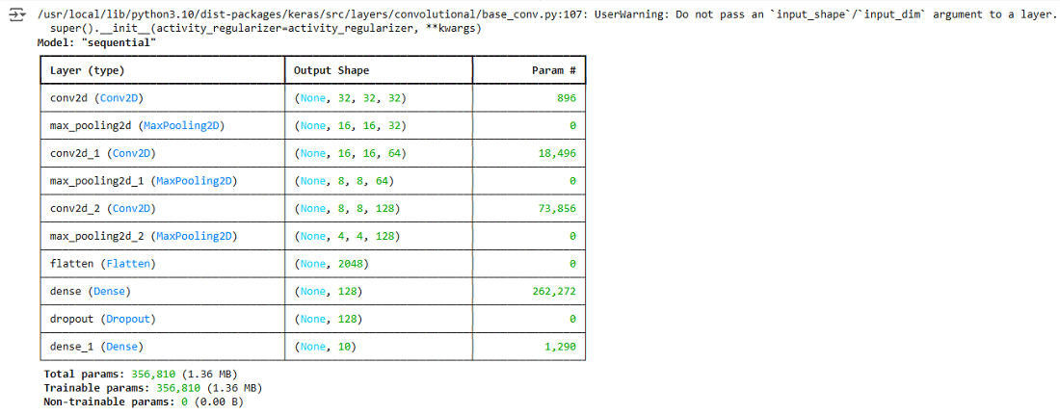
Explanation:
- Convolutional Layers: Extract spatial features using learnable filters.
- Pooling Layers: Reduce spatial dimensions, controlling computational complexity.
- Flatten Layer: Prepares data for the dense layers by converting multi-dimensional data into a 1D vector.
- Dense Layers: Perform high-level reasoning based on extracted features.
- Dropout Layer: Prevents overfitting by randomly disabling neurons during training.
- Output Layer: Produces probability distributions over the 10 classes.
4. Compiling the Model
Compiling the model involves specifying the optimizer, loss function, and evaluation metrics.
Code Implementation:
# Compile the model
cnn_model.compile(optimizer='adam',
loss='categorical_crossentropy',
metrics=['accuracy'])
Explanation:
- Optimizer (Adam): Adaptive optimizer that adjusts learning rates for each parameter, facilitating efficient training.
- Loss Function (Categorical Crossentropy): Suitable for multi-class classification tasks with one-hot encoded labels.
- Metrics (Accuracy): Tracks the proportion of correctly classified samples.
5. Training the CNN
Training the model involves feeding it the training data, allowing it to learn the underlying patterns.
Code Implementation:
# Define training parameters
epochs = 25
batch_size = 64

# Train the model
history = cnn_model.fit(train_images, train_labels,
epochs=epochs,
batch_size=batch_size,
validation_split=0.2,
verbose=1)
Explanation:
- Epochs (25): Number of complete passes through the training dataset.
- Batch Size (64): Number of samples processed before the model updates weights.
- Validation Split (0.2): Allocates 20% of the training data for validation to monitor model performance on unseen data during training.
6. Evaluating Model Performance
After training, it's essential to evaluate the model's performance on the test dataset to assess its generalization capabilities.
Code Implementation:
# Evaluate the model on test data
test_loss, test_accuracy = cnn_model.evaluate(test_images, test_labels, verbose=2)
print(f"Test Accuracy: {test_accuracy * 100:.2f}%")
print(f"Test Loss: {test_loss:.4f}")
Output:
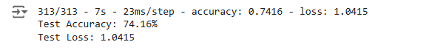

Explanation:
- Test Accuracy: Percentage of correctly classified test samples.
- Test Loss: Quantifies the discrepancy between predicted and actual labels on the test set.
7. Visualizing Training Progress
Visualizing training and validation metrics helps in understanding the model's learning behavior and diagnosing potential issues like overfitting.
Code Implementation:
import matplotlib.pyplot as plt

# Plot training & validation accuracy values
plt.figure(figsize=(14, 5))

plt.subplot(1, 2, 1)
plt.plot(history.history['accuracy'], label='Training Accuracy', marker='o')
plt.plot(history.history['val_accuracy'], label='Validation Accuracy', marker='o')
plt.title('Model Accuracy Over Epochs')
plt.xlabel('Epoch')
plt.ylabel('Accuracy')
plt.legend(loc='lower right')

# Plot training & validation loss values
plt.subplot(1, 2, 2)
plt.plot(history.history['loss'], label='Training Loss', marker='o')
plt.plot(history.history['val_loss'], label='Validation Loss', marker='o')
plt.title('Model Loss Over Epochs')
plt.xlabel('Epoch')
plt.ylabel('Loss')
plt.legend(loc='upper right')

plt.show()
Output:
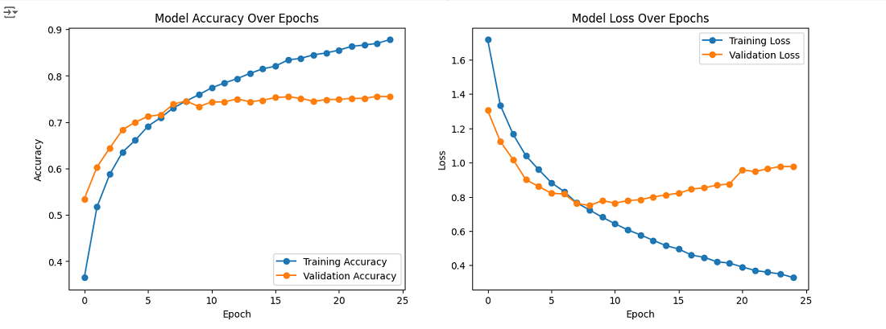
Explanation:
- Accuracy Plot: Shows how the model's accuracy improves over epochs for both training and validation sets.
- Loss Plot: Illustrates the decrease in loss over epochs for both training and validation sets.
- Indicators:
  - Overfitting: When validation loss starts increasing while training loss decreases.
  - Underfitting: When both training and validation loss remain high.
8. Saving and Loading the Model
Once satisfied with the model's performance, it's prudent to save it for future use without retraining.
Code Implementation:
# Save the model to disk
model_save_path = 'cnn_cifar10_model.h5'
cnn_model.save(model_save_path)
print(f"Model saved to {model_save_path}")

# Load the model from disk
loaded_model = tf.keras.models.load_model(model_save_path)
print("Model loaded successfully.")

# Verify loaded model performance
loaded_test_loss, loaded_test_accuracy = loaded_model.evaluate(test_images, test_labels, verbose=2)
print(f"Loaded Model Test Accuracy: {loaded_test_accuracy * 100:.2f}%")
Explanation:
- Saving: Stores the model architecture, weights, and optimizer state in a single HDF5 file.
- Loading: Retrieves the model for inference or further training without redefining the architecture.

The Need for RNNs

Introduction
In the realm of deep learning, Recurrent Neural Networks (RNNs) have emerged as a powerful architecture for processing sequential data. Unlike traditional feedforward neural networks, which assume all inputs and outputs are independent of each other, RNNs are designed to recognize patterns in sequences of data, such as time series, text, or speech. This article explores the fundamental reasons why RNNs are essential, delving into their theoretical foundations and practical applications.
1. Understanding Sequential Data
Sequential data refers to data where the order of the elements matters. Each data point is dependent on the previous ones, making the sequence contextually rich. Examples include:
- Time Series Data: Stock prices, weather data, sensor readings.
- Natural Language: Sentences and documents where word order affects meaning.
- Audio Signals: Speech recognition and music.
Key Characteristics:
- Temporal Dependency: Future data points depend on past values.
- Variable Length: Sequences can vary in length, requiring flexible models.
- Contextual Information: The meaning or value of a data point can depend on its position in the sequence.
2. Limitations of Feedforward Neural Networks
Traditional neural networks, such as multilayer perceptrons (MLPs), are ill-suited for sequential data due to:
- Fixed Input and Output Sizes: Unable to handle variable-length sequences.
- Lack of Memory: No mechanism to retain information about previous inputs.
- Independent Processing: Assumes each input is independent, ignoring temporal dependencies.
Illustrative Example:
Consider trying to predict the next word in a sentence using an MLP. The network cannot remember the previous words, leading to poor predictions that don't make sense contextually.
3. Introduction to Recurrent Neural Networks
Recurrent Neural Networks are designed to address these limitations by introducing loops within the network, allowing information to persist over time.
Key Features:
- Hidden State: Maintains a memory of past inputs.
- Shared Weights: The same weights are applied at each time step, making the model applicable to variable-length sequences.
- Sequential Processing: Processes data one step at a time, updating the hidden state accordingly.
4. Mathematical Foundations of RNNs
At each time step ttt, the RNN computes:
1. Hidden State Update:
ht=σ(Whhht−1+Wxhxt+bh)ht​=σ(Whh​ht−1​+Wxh​xt​+bh​)
Where:
ht=Hidden state at time tht​=Hidden state at time t
ht−1=Hidden state from the previous time stepht−1​=Hidden state from the previous time step
xt=Input at time 𝑡 xt​=Input at time t
Whh,Wxh=Weight matricesWhh​,Wxh​=Weight matrices
bh=Bias vectorbh​=Bias vector
σ= Activation function (e.g., tanh or ReLU)σ= Activation function (e.g., tanh or ReLU)
2. Output Calculation:
yt=ϕ(Whyht+by)yt​=ϕ(Why​ht​+by​)
Where:
yt=Output at time t yt​=Output at time t
Why=Weight matrix from hidden state to outputWhy​=Weight matrix from hidden state to output
by=Bias vectorby​=Bias vector
ϕ=Activation function (e.g., softmax for classification)ϕ=Activation function (e.g., softmax for classification)
Explanation:
- The hidden state htht​ incorporates information from both the current input xtxt​​ and the previous hidden state ht−1ht−1​, effectively capturing temporal dependencies.
- The output ytyt​​ is computed based on the current hidden state.
5. Applications of RNNs
Natural Language Processing (NLP):
- Language Modeling: Predicting the next word in a sentence.
- Machine Translation: Translating text from one language to another.
- Sentiment Analysis: Determining the sentiment of a sentence or document.
Time Series Analysis:
- Forecasting: Predicting future values based on historical data.
- Anomaly Detection: Identifying unusual patterns in data streams.
Speech Recognition and Generation:
- Transcription: Converting audio signals to text.
- Speech Synthesis: Generating human-like speech from text.
6. Implementing a Basic RNN in TensorFlow
To solidify our understanding, let's implement a simple RNN for sequence classification using TensorFlow.
Problem Statement:
Classify sequences of integers as either "even" or "odd" based on the sum of their elements.
Step 1: Import Libraries
import tensorflow as tf
import numpy as np
from tensorflow.keras.models import Sequential
from tensorflow.keras.layers import SimpleRNN, Dense
Step 2: Generate Synthetic Data
# Generate sequences of random integers
def generate_sequences(num_sequences, max_length, vocab_size):
sequences = []
labels = []
for _ in range(num_sequences):
length = np.random.randint(1, max_length + 1)
seq = np.random.randint(0, vocab_size, length)
label = np.sum(seq) % 2 # 0 if sum is even, 1 if odd
sequences.append(seq)
labels.append(label)
return sequences, labels

# Parameters
num_sequences = 1000
max_length = 10
vocab_size = 10

# Generate data
sequences, labels = generate_sequences(num_sequences, max_length, vocab_size)
Step 3: Pad Sequences
from tensorflow.keras.preprocessing.sequence import pad_sequences

# Pad sequences to the same length
padded_sequences = pad_sequences(sequences, maxlen=max_length, padding='post')

# Convert labels to numpy array
labels = np.array(labels)
Step 4: Build the RNN Model
# Define the model
model = Sequential()
model.add(SimpleRNN(32, input_shape=(max_length, 1)))
model.add(Dense(1, activation='sigmoid'))

# Compile the model
model.compile(optimizer='adam', loss='binary_crossentropy', metrics=['accuracy'])
Explanation:
- SimpleRNN Layer: Processes the input sequences and captures temporal dependencies.
- Dense Layer: Outputs a probability indicating whether the sequence sum is even or odd.
Step 5: Train the Model
# Reshape input data
X = padded_sequences.reshape((num_sequences, max_length, 1))
y = labels

# Train the model
model.fit(X, y, epochs=10, batch_size=32, validation_split=0.2)
Step 6: Evaluate the Model
# Evaluate on the training data
loss, accuracy = model.evaluate(X, y)
print(f"Accuracy: {accuracy * 100:.2f}%")
Output:

Step 7: Make Predictions
# Predict on new data
test_seq = np.array([[1, 3, 5]])
test_seq_padded = pad_sequences(test_seq, maxlen=max_length, padding='post')
test_seq_reshaped = test_seq_padded.reshape((1, max_length, 1))

prediction = model.predict(test_seq_reshaped)
predicted_label = int(prediction.round()[0][0])
print(f"Predicted Label: {'Even' if predicted_label == 0 else 'Odd'}")
Output:


🔁 What is RNN (Recurrent Neural Network)?
RNN (Recurrent Neural Network) is a type of neural network designed for sequential data. Unlike regular neural networks, RNNs have a memory of previous inputs, which makes them ideal for tasks like:
- 🗣️ Speech recognition
- ✍️ Text generation
- 📈 Time series prediction
- 🧠 Natural language processing (NLP)
✅ Key Idea:
Each output in RNN depends not only on the current input, but also on the previous hidden state, making it effective for sequences.

🛠️ How to Implement RNN in Python using TensorFlow/Keras
Here’s a basic example of using RNN to predict the next number in a sequence.

📦 1. Install Requirements
pip install tensorflow

🧠 2. Build a Simple RNN Model
import numpy as np
from tensorflow.keras.models import Sequential
from tensorflow.keras.layers import SimpleRNN, Dense

# Example data: sequences of 3 numbers, predicting the 4th
X = np.array([
[ [0], [1], [2] ],
[ [1], [2], [3] ],
[ [2], [3], [4] ],
[ [3], [4], [5] ]
])
y = np.array([[3], [4], [5], [6]])

# Define the RNN model
model = Sequential()
model.add(SimpleRNN(10, activation='relu', input_shape=(3, 1)))
model.add(Dense(1))

model.compile(optimizer='adam', loss='mse')

# Train the model
model.fit(X, y, epochs=200, verbose=0)

# Predict the next number in the sequence [4, 5, 6]
test_input = np.array([ [ [4], [5], [6] ] ])
predicted = model.predict(test_input, verbose=0)
print("Predicted next number:", predicted)

📈 Output (Sample)
Predicted next number: [[7.01]]

🧮 RNN Structure Recap
At each time step t:
h_t = f(Wx * x_t + Wh * h_{t-1} + b)
Where:
- x_t = input at time t
- h_t = hidden state
- Wx, Wh = weights
- b = bias
- f = activation (like tanh or ReLU)

🔥 Want to go further?
You can try:
- 🧠 LSTM or GRU (advanced RNNs for long sequences)
- ✍️ Text generation models
- 📈 Stock prediction using time series
Let me know if you'd like a specific application (like chatbot, music generation, etc.)!
🤔 What is a Hidden State in RNN?
In Recurrent Neural Networks (RNNs), the hidden state is like the memory of the network.

📦 Simple Definition:
The hidden state stores information about previous inputs in the sequence and helps the model make better predictions based on context.

Excellent question — understanding embeddings is a major step in mastering RNNs, LSTMs, GRUs, and even more advanced systems like RAG. Let's break it down clearly and simply:

🧠 What Are Embeddings?
An embedding is a dense vector representation of discrete input — usually words, subwords, or characters.
For example:
- The word "cat" might be represented as [0.12, -0.23, 0.44, ..., 0.06] instead of [0, 0, 1, 0, ..., 0] (which is a one-hot vector).
- The character 'c' might be mapped to an index like 5, and then turned into a vector via the embedding matrix.
🔑 Embeddings convert integers into learnable, meaningful vectors.

✅ Why Are Embeddings Used?
Because:
- Inputs to neural networks must be numbers
- One-hot encoding is sparse and not scalable
- Embeddings let the model learn similarities between words or characters

🔸 One-Hot Encoding vs Embedding
Word | One-Hot (100D) | Embedding (8D)
"king" | [0, 0, 1, 0, ...] | [0.12, -0.55, 0.34, ..., 0.09]
"queen" | [0, 1, 0, 0, ...] | [0.15, -0.53, 0.30, ..., 0.07]
💡 Now "king" and "queen" may end up with similar embeddings, capturing the concept of royalty — something one-hot can't do.

🔄 Where Embeddings Fit in RNN / LSTM / GRU
Input Flow:
- Text (e.g., "hello")
- Ordinal encoding → [1, 5, 2, 2, 3]
- Embedding layer turns this into dense vectors:
- model.add(Embedding(input_dim=vocab_size, output_dim=8))
- The RNN/LSTM/GRU now works with dense sequences instead of raw integers.
✅ Why this helps:
- The network sees a meaningful continuous representation of each character or word.
- It learns which words are similar in context.

🧠 What About RAG (Retrieval-Augmented Generation)?
RAG (used in systems like ChatGPT + docs, or Google's Bard with search) also uses embeddings, but in a different way:
Model | Use of Embeddings
RNN/LSTM/GRU | For turning words into vectors before processing
RAG | For searching and retrieving relevant documents from a database
In RAG:
- Your query → embedded vector
- System finds the most similar documents based on vector similarity
- Then, generation happens (using GPT or similar)

🔚 Summary
Concept | What It Is | Why It Matters
Embedding | A dense vector for a word/char/token | Makes training efficient, captures meaning
In RNN/LSTM | Input layer that maps integers to vectors | Helps model understand language patterns
In RAG | Used to retrieve semantically similar content | Connects your query with useful context

Would you like a diagram or a live example where you see embeddings being used in code?

LSTM and GRU Units

Introduction
While Recurrent Neural Networks (RNNs) are powerful, they suffer from limitations such as the vanishing gradient problem, which hampers their ability to learn long-term dependencies. To address these issues, advanced architectures like Long Short-Term Memory (LSTM) and Gated Recurrent Unit (GRU) were developed. These units incorporate gating mechanisms that regulate the flow of information, enabling the network to capture both short-term and long-term dependencies more effectively. This article delves into the theory behind LSTM and GRU units, their architectures, and how to implement them using TensorFlow.
1. Challenges with Standard RNNs
Vanishing and Exploding Gradients:
- Vanishing Gradients: Gradients shrink exponentially during backpropagation, making it difficult for the network to learn long-term dependencies.
- Exploding Gradients: Gradients grow exponentially, causing numerical instability.
Implications:
- Difficulty in training RNNs on sequences with long-range dependencies.
- Inability to retain information from earlier time steps.
2. Introduction to LSTM Units
Long Short-Term Memory (LSTM) units were introduced by Hochreiter and Schmidhuber in 1997 to overcome the vanishing gradient problem. LSTMs incorporate gates that control the flow of information, effectively deciding what to remember and what to forget.
Architecture and Gates
An LSTM unit consists of:
1. Cell State (C_{t}) : The memory of the network, carrying information across time steps.
2. Hidden State (h_{t}) : Output at time ttt, also serves as input to the next time step.
3. Gates:
- Forget Gate (f_{t}): Decides what information to discard from the cell state.
- Input Gate (i_{t}): Determines what new information to add to the cell state.
- Output Gate (o_{t}​): Controls the output and what information to pass to the hidden state.
Mathematical Equations
At each time step t :
1. Forget Gate:
ft​=σ(Wf​⋅[ht−1​,xt​]+bf​)
2. Input Gate
it​=σ(Wi​⋅[ht−1​,xt​]+bi​)C~t​=tanh(WC​⋅[ht−1​,xt​]+bC​)
3. Cell State Update:
Ct​=ft​∗Ct−1​+it​∗C~t​
4. Output Gate:
ot​=σ(Wo​⋅[ht−1​,xt​]+bo​)
5. Hidden State Update:
ht​=ot​∗tanh(Ct​)
Explanation:
- Sigmoid Function (σ) outputs values between 0 and 1, functioning as a gate.
- Tanh Function scales values between -1 and 1, adding non-linearity.
- Element-wise Multiplication (∗) allows for gating mechanisms.
3. Introduction to GRU Units
Gated Recurrent Unit (GRU) is a simplified version of LSTM introduced by Cho et al. in 2014. GRUs combine the forget and input gates into a single update gate, reducing computational complexity.
Architecture
GRUs consist of:
- Reset Gate (rt​​): Determines how to combine the new input with the previous memory.
- Update Gate (zt​): Controls how much of the previous memory to keep.
Mathematical Equations
At each time step t:
1. Update Gate:
zt​=σ(Wz​⋅[ht−1​,xt​])
2. Reset Gate:
rt​=σ(Wr​⋅[ht−1​,xt​])
3. Candidate Hidden State:
h~t​=tanh(Wh​⋅[rt​∗ht−1​,xt​])
4. Hidden State Update:
ht​=(1−zt​)∗ht−1​+zt​∗h~t​
Explanation:
- Fewer Gates: Simplifies the architecture compared to LSTM.
- Combines Memory Mechanisms: The update gate handles both forgetting and adding new information.
4. Comparing LSTM and GRU
Feature | LSTM | GRU
Number of Gates | Three(Input,forget,Output) | Two(Update, Reset)
Computational Cost | Higher due to more parameters | Lower due to simplified design
Performance | Effective for complex dependencies | Comparable, sometimes better
Usage | Preferred when dataset is large | Preffered for smaller datasets
Key Takeaways:
- LSTM offers more control but is computationally heavier.
- GRU is simpler and often performs similarly to LSTM.
5. Implementing LSTM and GRU in TensorFlow
Let's implement both LSTM and GRU models for a sequence classification task.
Problem Statement:
Classify movie reviews as positive or negative using the IMDB dataset.
Step 1: Import Libraries
import tensorflow as tf
from tensorflow.keras.datasets import imdb
from tensorflow.keras.preprocessing import sequence
from tensorflow.keras.models import Sequential
from tensorflow.keras.layers import LSTM, GRU, Dense, Embedding
Step 2: Load and Preprocess Data
# Parameters
vocab_size = 10000
max_length = 500

# Load the IMDB dataset
(X_train, y_train), (X_test, y_test) = imdb.load_data(num_words=vocab_size)

# Pad sequences
X_train = sequence.pad_sequences(X_train, maxlen=max_length)
X_test = sequence.pad_sequences(X_test, maxlen=max_length)
Step 3: Build LSTM Model
# Define LSTM model
def build_lstm_model():
model = Sequential()
model.add(Embedding(vocab_size, 128, input_length=max_length))
model.add(LSTM(64))
model.add(Dense(1, activation='sigmoid'))
return model

# Instantiate and compile the model
lstm_model = build_lstm_model()
lstm_model.compile(optimizer='adam', loss='binary_crossentropy', metrics=['accuracy'])
Step 4: Train LSTM Model
# Train the LSTM model
lstm_history = lstm_model.fit(X_train, y_train, epochs=3, batch_size=64, validation_split=0.2)
Step 5: Build GRU Model
# Define GRU model
def build_gru_model():
model = Sequential()
model.add(Embedding(vocab_size, 128, input_length=max_length))
model.add(GRU(64))
model.add(Dense(1, activation='sigmoid'))
return model

# Instantiate and compile the model
gru_model = build_gru_model()
gru_model.compile(optimizer='adam', loss='binary_crossentropy', metrics=['accuracy'])
Step 6: Train GRU Model
# Train the GRU model
gru_history = gru_model.fit(X_train, y_train, epochs=3, batch_size=64, validation_split=0.2)
Step 7: Evaluate Models
# Evaluate LSTM model
lstm_loss, lstm_accuracy = lstm_model.evaluate(X_test, y_test)
print(f"LSTM Test Accuracy: {lstm_accuracy * 100:.2f}%")

# Evaluate GRU model
gru_loss, gru_accuracy = gru_model.evaluate(X_test, y_test)
print(f"GRU Test Accuracy: {gru_accuracy * 100:.2f}%")
Output:
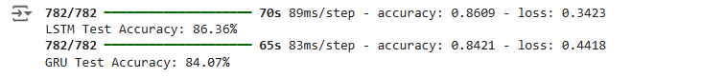
6. Use Cases and Applications
LSTM Applications:
Language Translation
LSTMs are well-suited for language translation tasks because they can capture the context of a sentence over long sequences, allowing for a more nuanced understanding of the structure and meaning of each phrase. For instance, in translating from English to French, LSTMs can help retain grammatical nuances, such as gendered nouns or complex verb conjugations, that are often critical to accurate translation. By capturing dependencies across long sentences, they ensure that even words positioned far apart maintain the intended meaning. Additionally, LSTMs help prevent issues such as lost context when translating idiomatic expressions or phrases with ambiguous meanings.
Speech Recognition
In speech recognition, LSTMs process continuous audio data to transform spoken language into text. LSTMs are ideal for this application as they manage sequential data with temporal dependencies, which is vital for understanding spoken language where context builds gradually. For example, when transcribing a long sentence, early words provide context for later words, influencing the overall interpretation. LSTMs also help manage accents, pauses, and variations in speed by storing information about previous sounds, ensuring that transcription remains accurate over extended audio sequences.
Music Generation
LSTMs in music generation model the temporal structure of musical compositions, creating sequences that follow musical rules and maintain coherent themes. By "remembering" previous notes, rhythms, and patterns, LSTMs can create harmonious pieces that exhibit consistent style and mood. In jazz improvisation, for example, LSTMs can generate melodic lines that respect the preceding chords and rhythm patterns, creating a more natural flow in the composition. They are also useful in generating genres with strict sequential structures, like classical compositions, where themes and motifs recur and evolve over time.
GRU Applications:
Real-Time Predictions
GRUs are particularly effective in real-time predictions because of their streamlined architecture, which makes them faster and more computationally efficient than other recurrent neural networks, such as LSTMs. In real-time applications like fraud detection or online ad targeting, GRUs quickly process incoming data to make instantaneous predictions. Their efficiency enables quicker updates and predictions, which is critical for situations where every second counts. For example, in financial transactions, GRUs can help detect anomalies in real-time, identifying potentially fraudulent behavior as it occurs, reducing potential losses.
Text Classification
GRUs are widely used in text classification tasks, such as sentiment analysis and topic classification, where the goal is to classify entire sentences or documents based on the overall tone or topic. GRUs’ ability to handle sequential text data allows them to capture the important words and phrases that define the sentiment or theme of the text. For sentiment analysis, GRUs process the text to determine whether the sentiment is positive, negative, or neutral, even in lengthy reviews or tweets. In topic classification, GRUs analyze documents to identify overarching themes like politics, technology, or sports, making them useful for content recommendation engines or automated content moderation.
Time Series Forecasting
GRUs are also effective in time series forecasting, where the model predicts future data points based on historical sequences. Their efficient design helps capture temporal dependencies in time series data, making GRUs ideal for applications like stock price prediction, weather forecasting, and energy consumption analysis. For instance, in stock price prediction, GRUs can help track trends and patterns in historical price data, aiding in forecasting future movements. In weather prediction, GRUs analyze past weather data to predict future temperatures, precipitation, or other climate conditions, helping meteorologists make accurate forecasts.

Time Series Prediction with RNNs

Introduction
Time series prediction involves forecasting future values based on previously observed data points over time. Applications range from stock price forecasting and weather prediction to demand planning and anomaly detection. Recurrent Neural Networks (RNNs), with their ability to capture temporal dependencies, are well-suited for modeling time series data. This article explores how to implement RNNs for time series prediction, focusing on practical steps, code implementations, and best practices.
1. Understanding Time Series Data
Time Series Data consists of sequences of observations collected over time intervals. Key characteristics include:
- Temporal Dependency: Current values depend on past values.
- Trend Components: Long-term increase or decrease in the data.
- Seasonality: Regular patterns repeating over fixed periods.
- Noise: Random variability in the data.
2. Challenges in Time Series Prediction
- Non-Stationarity: Statistical properties change over time.
- Autocorrelation: Observations are correlated with past values.
- Feature Engineering: Selecting appropriate lags and external variables.
- Overfitting: Risk of the model capturing noise instead of the underlying pattern.
3. Data Preparation for Time Series
Steps:
- Normalization: Scaling data to a suitable range.
- Creating Sequences: Transforming time series data into supervised learning format.
- Train-Test Split: Splitting data while preserving temporal order.
Example:
Given a time series [x1​,x2​,x3​,.....,xn​] , we create input-output pairs:
- Input: [xt−3​,xt−2​,xt−1​]
- Output: xt​
4. Building RNN Models for Time Series
SimpleRNN:
The SimpleRNN layer is the foundational building block of recurrent neural networks. It processes input sequences by iteratively applying the same set of weights to the current input and the previous hidden state.
- Basic RNN layer, suitable for short sequences:
  - Explanation: SimpleRNNs are straightforward to implement and understand. They work by taking an input vector and combining it with the hidden state from the previous time step to produce the current hidden state. This makes them suitable for modeling short sequences where long-term dependencies are minimal.
  - Use Cases: Applications like basic sentiment analysis or simple time series forecasting, where the sequence length is limited and dependencies do not span many time steps.
- Prone to vanishing gradient problems:
  - Explanation: During training, RNNs use backpropagation through time (BPTT) to update weights. In SimpleRNNs, gradients can exponentially decay as they are propagated backwards through many time steps. This "vanishing gradient" makes it difficult for the network to learn long-term dependencies, as the contributions of earlier time steps become negligible.
  - Implications: This limitation restricts the effectiveness of SimpleRNNs in handling complex sequences where information from earlier in the sequence is important for prediction.
LSTM:
LSTM networks are an advanced type of RNN specifically designed to overcome the vanishing gradient problem. They introduce a more complex cell structure that can maintain information over long periods.
- Handles long-term dependencies:
  - Explanation: LSTMs incorporate memory cells and gating mechanisms (input, output, and forget gates) that regulate the flow of information. This allows them to preserve relevant information over extended time intervals, effectively capturing long-term dependencies in the data.
  - Mechanism: The gates control which information is added to or removed from the cell state. The forget gate decides what information to discard, the input gate determines what new information to store, and the output gate controls what information to output.
- Effective for sequences with complex temporal structures:
  - Explanation: LSTMs excel in tasks where the context from earlier in the sequence significantly influences the outcome. Their ability to model complex temporal patterns makes them suitable for a wide range of applications.
  - Use Cases: Natural language processing (e.g., machine translation, text generation), speech recognition, and time series forecasting where patterns may span long sequences.
GRU:
GRUs are a newer variant of RNNs that aim to provide a balance between the simplicity of SimpleRNNs and the powerful capabilities of LSTMs.
- Simplified version of LSTM:
  - Explanation: GRUs combine the input and forget gates into a single update gate and merge the cell state and hidden state, resulting in a more streamlined architecture. This simplification reduces the number of parameters and computational complexity.
  - Mechanism: The GRU uses an update gate to decide how much of the previous information to retain and a reset gate to determine how to combine the new input with the previous memory.
- Computationally efficient:
  - Explanation: Due to their simpler structure, GRUs require less computational power and memory, making them faster to train and execute compared to LSTMs.
  - Use Cases: Situations where computational resources are limited or when dealing with large datasets where training speed is a concern. GRUs are effective in similar applications as LSTMs but offer efficiency advantages.
5. Implementing Time Series Prediction in TensorFlow
Problem Statement:
Predict the daily closing price of a stock using historical data.
Step 1: Import Libraries
import tensorflow as tf
import pandas as pd
import numpy as np
import matplotlib.pyplot as plt
Step 2: Load and Preprocess Data
Dataset Link : https://www.kaggle.com/datasets/henryshan/apple-stock-price
# Load stock price data
data = pd.read_csv('/content/stock_prices.csv')
prices = data['Close'].values

# Normalize data
from sklearn.preprocessing import MinMaxScaler
scaler = MinMaxScaler(feature_range=(0, 1))
prices_scaled = scaler.fit_transform(prices.reshape(-1, 1))
Step 3: Create Sequences
def create_sequences(data, seq_length):
X = []
y = []
for i in range(len(data) - seq_length):
X.append(data[i:i+seq_length])
y.append(data[i+seq_length])
return np.array(X), np.array(y)

seq_length = 60 # Use past 60 days to predict the next day
X, y = create_sequences(prices_scaled, seq_length)

# Split into training and test sets
split = int(0.8 * len(X))
X_train, X_test = X[:split], X[split:]
y_train, y_test = y[:split], y[split:]
Step 4: Build the LSTM Model
# Reshape input data
X_train = X_train.reshape((X_train.shape[0], seq_length, 1))
X_test = X_test.reshape((X_test.shape[0], seq_length, 1))

# Define the model
model = tf.keras.Sequential([
tf.keras.layers.LSTM(50, return_sequences=True, input_shape=(seq_length, 1)),
tf.keras.layers.LSTM(50),
tf.keras.layers.Dense(1)
])

# Compile the model
model.compile(optimizer='adam', loss='mean_squared_error')
Explanation:
- return_sequences=True: Ensures that the first LSTM layer outputs the full sequence for the next LSTM layer.
- Loss Function (MSE): Suitable for regression tasks.
Step 5: Train the Model
history = model.fit(X_train, y_train, epochs=20, batch_size=32, validation_data=(X_test, y_test))
Step 6: Evaluate and Predict
# Predict on test data
predictions = model.predict(X_test)

# Inverse transform to get actual prices
predictions_inverse = scaler.inverse_transform(predictions)
y_test_inverse = scaler.inverse_transform(y_test.reshape(-1, 1))
Step 7: Visualize Results
plt.figure(figsize=(14, 5))
plt.plot(y_test_inverse, label='Actual Price')
plt.plot(predictions_inverse, label='Predicted Price')
plt.title('Stock Price Prediction')
plt.xlabel('Time')
plt.ylabel('Price')
plt.legend()
plt.show()
Output:
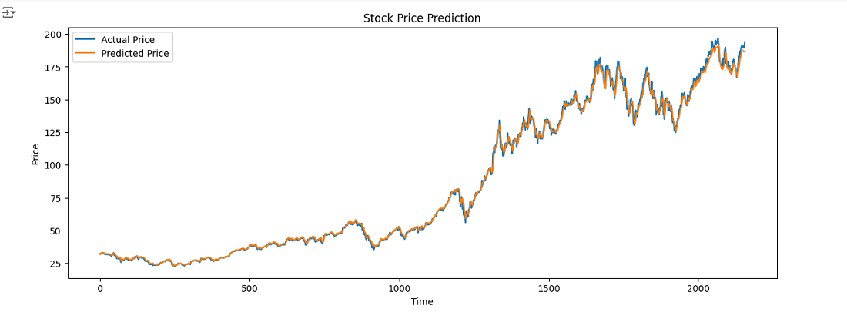
Explanation:
- Visual comparison helps assess the model's performance in capturing trends.
6. Evaluating Model Performance
Metrics:
- Mean Squared Error (MSE): Measures average squared difference between predicted and actual values.
- Root Mean Squared Error (RMSE): Square root of MSE, provides error in original units.
- Mean Absolute Error (MAE): Average absolute difference.
Code Implementation:
from sklearn.metrics import mean_squared_error, mean_absolute_error

mse = mean_squared_error(y_test_inverse, predictions_inverse)
rmse = np.sqrt(mse)
mae = mean_absolute_error(y_test_inverse, predictions_inverse)

print(f"MSE: {mse:.4f}")
print(f"RMSE: {rmse:.4f}")
print(f"MAE: {mae:.4f}")
Output:
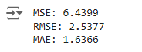
7. Hyperparameter Tuning and Best Practices
Hyperparameters to Consider:
- Sequence Length: Experiment with different window sizes.
- Number of Layers and Units: More layers and units can capture complex patterns but may overfit.
- Dropout Regularization: Prevents overfitting by randomly dropping units during training.
- Learning Rate: Adjust optimizer settings for better convergence.
Best Practices:
- Data Stationarity: Apply differencing or detrending if necessary.
- Feature Engineering: Incorporate additional features like moving averages, volatility indices.
- Cross-Validation: Use time series cross-validation techniques.

